**Laboratory Health and Safety Signage**

**Introduction**

To help ensure the safety of staff, students and visitors clear, accurate health and safety signage should be displayed at each entry point to a laboratory or working area. The purpose of this signage is to warn anyone entering the area of the key hazards that are present and make them aware of any specific safety requirements (e.g. PPE) and prohibitions that may apply. While laboratory users may be familiar with the hazards and safety requirements in their workspaces the same cannot be said for visitors, contractors and the emergency services who will rely on signage in the first instance entering an unfamiliar workplace.

To ensure that health and safety signage is easily understood and a consistent approach is taken the requirements for safety signage are set out in the Safety signs and signals (The Health and Safety Regulations) 1996 and further clarified in the Approved Code of Practice (L64) published by the HSE:

<https://www.hse.gov.uk/pubns/books/l64.htm>

Any safety signage displayed on University premises should meet these requirements with care taken to ensure that key safety information is presented without cluttering the message with extraneous information. The following conventions are adopted for safety signage displayed at the entry points to University research laboratories and workshops.

**Note: While it is permissible for safety warning signs to include the hazard symbol only, we strongly recommend that the signs selected include relevant explanatory text underneath to avoid any ambiguity and assist those who may be less familiar with the meaning of the specific symbols e.g. cleaning staff, contractors etc.**

**Laboratory Warning Signage (Chemical)**

Signage should be clearly displayed at the entry point of the laboratory focussing on the major hazards and any other safety instructions (e.g. PPE requirements / access restrictions) to avoid confusion while still providing key safety information. Hazard signage should be in the standard yellow / black triangle format and should include explanatory text to help reduce ambiguity. For most laboratories it will be sufficient to include the general warning sign (2) to indicate the presence of chemicals, where particularly hazardous chemicals are present consideration can be given to incorporating the toxic symbol (1) but note that the use of the “harmful chemicals” cross has been withdrawn for laboratory signage and should be avoided. Where particular hazards are present e.g. compressed gas cylinders / large quantities of flammable gases / liquids, biological or radiological hazards which could pose a significant risk to users / first responders then these must be clearly identified and the **relevant signage must be displayed.** (3)(4).

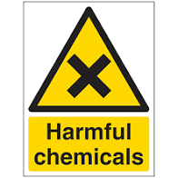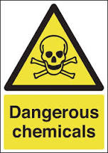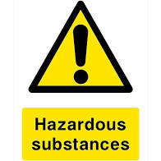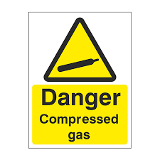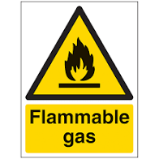

**1**

**2**

**4**

**3**

**Figure 1:** Standard laboratory warning signs (chemical).

**Laboratory Warning Signage (Biological)**

Laboratories where hazardous biological materials are used and / or stored should be clearly identified using the yellow and black biological hazard warning symbol (see figure 2). Please note that this sign is mandatory for all laboratories where biological hazards are likely to be present even where other hazards e.g. chemicals may also present a serious risk.

In addition to the biological hazard symbol, certain laboratories operating at Containment Levels 2 and 3 (CL2 and CL3) are required to display signage indicating the containment level of the area at the point of entry. There is no need to provide further specific detail on the nature of the biological materials present within the area.

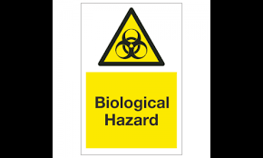 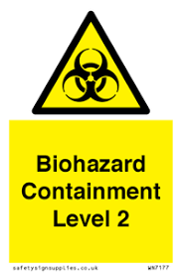

**Figure 2:** Example biohazard signage (including CL2 laboratory example)

**Laboratory Warning Signage (Radiation)**

Laboratories and other areas where radioactive sources are used or stored are required to have specific signage clearly displayed at the entrances which may vary depending on whether the laboratory is considered a “controlled area” or a “supervised area” (this is dependent on the nature of the work undertaken and the safety procedures required in the designated area).

In both cases it is necessary to display a yellow and black warning sign which includes the radiation warning symbol and the designation of the area. For controlled areas the signage should also incorporate an “authorised personnel only” prohibition warning sign as shown below in figure 3.

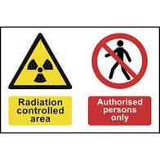 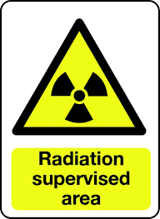

**Figure 3:** Example radiation warning signage for controlled and supervised areas

In addition to the standard warning signs, specific warning signs are also required for areas utilising unenclosed x-ray generators and class 3b and 4 lasers . Where an unenclosed x-ray system is in use the entrance to the area **must be** indicated using an illuminated warning sign with the HSE advising that the sign must have multiple redundancy in case of failure (see figure 4). Where an x-ray system is fully enclosed there is no need for additional signage at the entrance to the working area (although the equipment itself will generally include suitable signage on the cabinet).

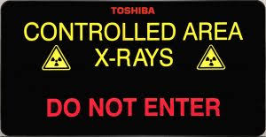

**Figure 4:** Example of an illuminated sign indicating an x-ray controlled area.

Ultraviolet radiation sources are most commonly fully enclosed within a piece of equipment (e.g. a light box or decontamination cabinet) where the source is fully or partially enclosed. Where this is the case a warning sign will be required on the equipment but not generally at the entrance to the working area. However, in areas where a source is present outwith an enclosure (e.g. overhead UV lighting) warning signs must be placed at the entry points.

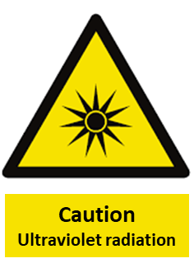

**Figure 5:** Ultraviolet radiation sign (required when source is not enclosed)

Class 3b and 4 laser systems should be located in a dedicated room. The entrance to the room should be clearly marked with an illuminated sign (preferably interlocked to the laser system) indicating when the laser is in use (note that these will include the laser hazard symbol). The entrance should **also** be clearly marked with a fixed sign indicating the class and type of laser along with contact details for the responsible person (see figure 6)

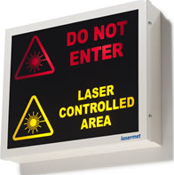 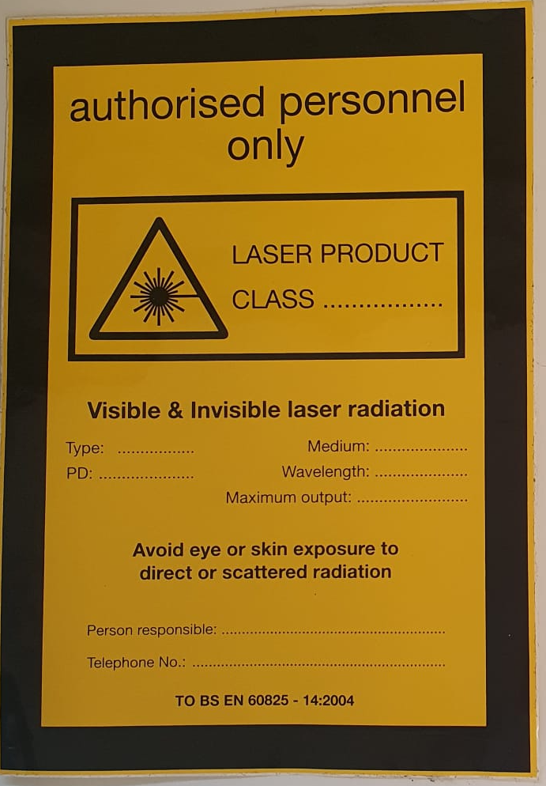

**Figure 6:** Laser safety signage (note that both types are required for each facility).

Signage should also be present at the entry point(s) to workplaces where magnetic or electromagnetic fields are present. The nature of the signage required will depend on the type and strength of the field but typical warning signs are shown in figure 7. It is worth noting that warning signs of this type will almost always be accompanied by prohibition signs to prevent the accidental entry of individuals who have been fitted with certain types of medical implant and/or implanted medical devices.

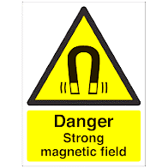 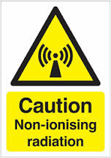

**Figure 7:** Warning signs for magnetic fields and non-ionising radiation.

**Mandatory Signage**

The signage present at each laboratory entrance should clearly and unambiguously indicate the minimum level of PPE that is required for anyone entering the area using the standard blue and white “mandatory” design. For most chemical laboratories the minimum standard will be safety glasses / goggles and a protective lab coat. It is recommended that this standard is adopted in all laboratories where chemicals are used but it is recognised that in some laboratories the use of safety glasses is not required / desirable and the requirements may be adjusted where the use of safety glasses would interfere with the work being undertaken so long as the risk of eye damage is risk assessed and controlled by other means (where required).

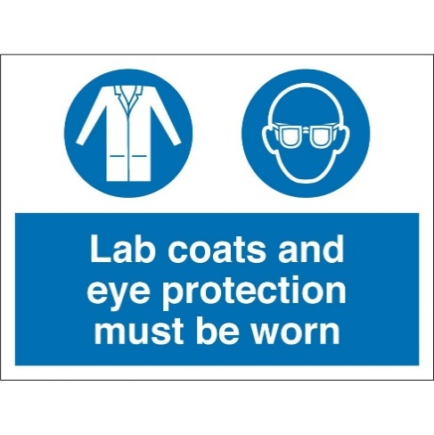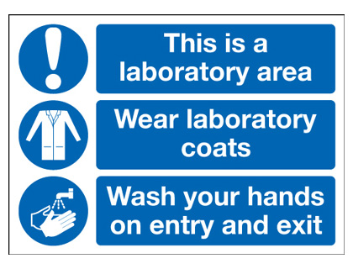

**Figure 8:** Example mandatory PPE signs.

The level of PPE will be determined by the work being undertaken, for example in biological laboratories eye protection may only be required when working with certain chemicals and where there is a risk of splashing outside of primary containment. Other PPE requirements may also apply in other areas e.g. use of laser safety goggles, face shields etc.

Single-use gloves are routinely worn within laboratory areas when carrying out research. However, their use is task-specific and while they will be worn for most experimental work they are not usually required at all times within the laboratory area (i.e. when writing up). On this basis are not usually included in mandatory PPE signage (except in areas where they must be worn at all times for technical and / or safety reasons).

**Prohibition Signage**

Other signs may also be placed on the door where additional information is required and/ or prohibitions apply, examples can be seen in figure 9. The use of the “do not touch with gloved hands” sign on laboratory and corridor doors should be considered but only where its presence does not cause clutter that may distract from other mandatory signage.

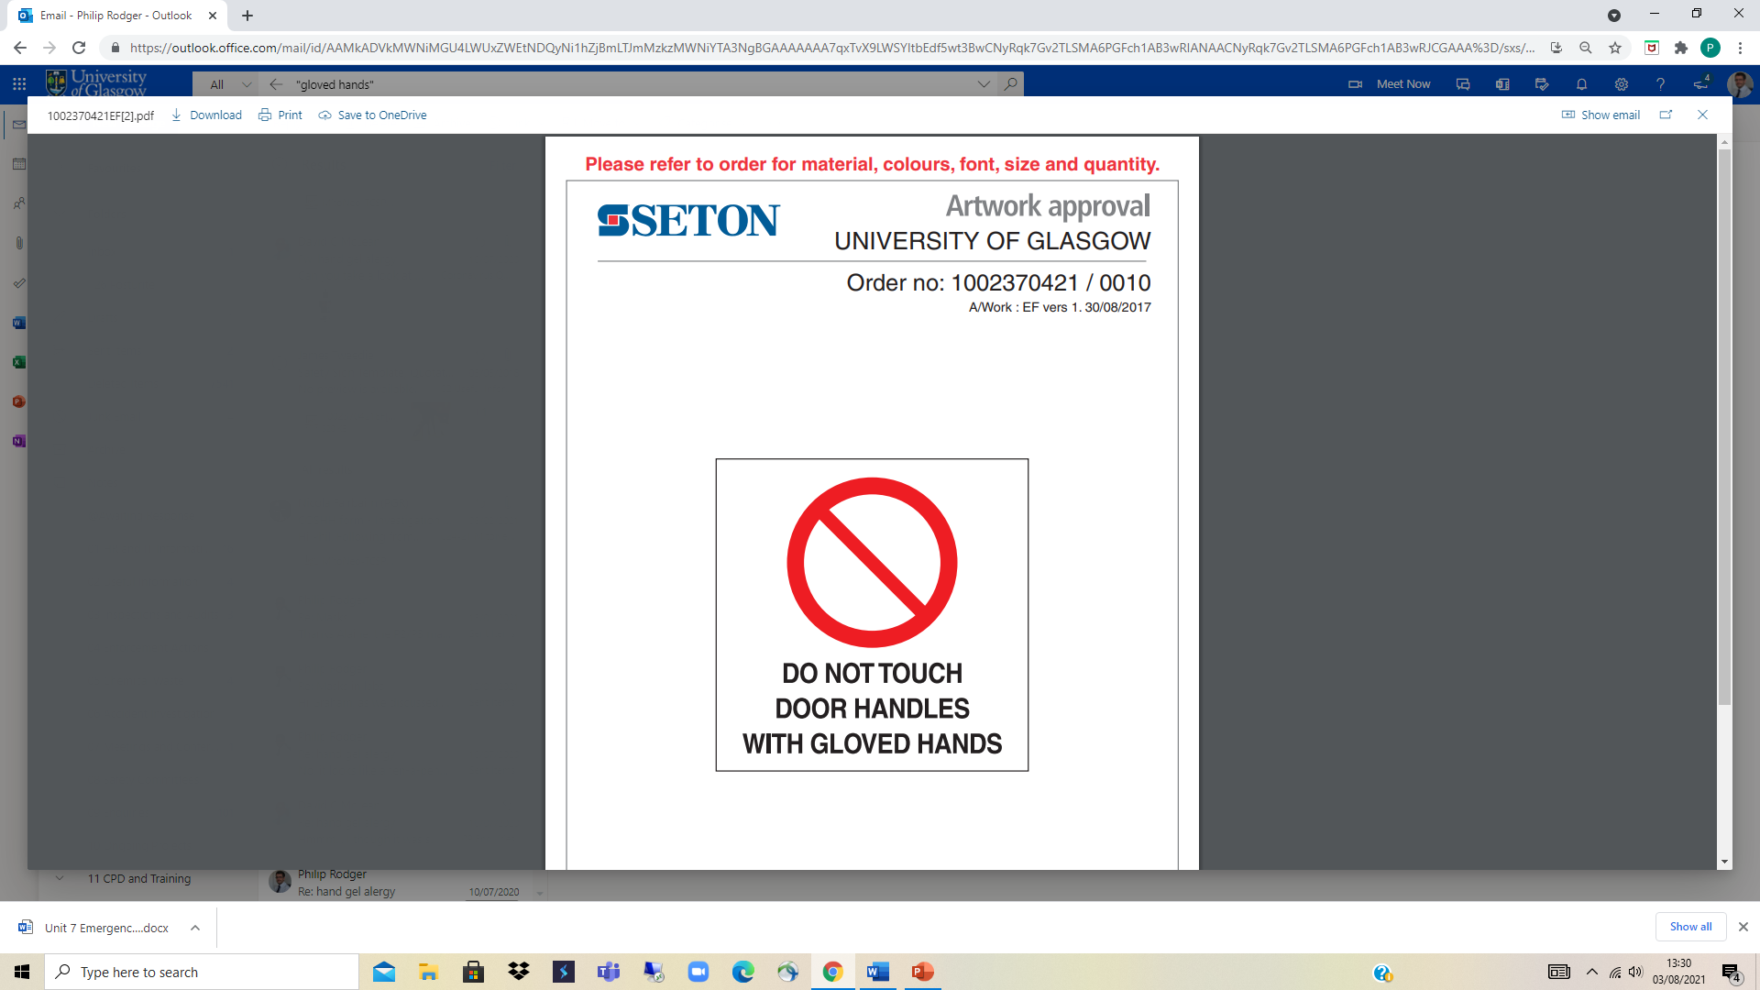 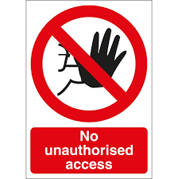 

**Figure 9:** Example prohibition signage

There are some cases where specific prohibition signs should always be displayed at the entry point to a laboratory or other working area. For example specified biological containment laboratories (CL2 and CL3) require to display signage restricting access to authorised personnel and working laboratories would expect to be designated as “no eating or drinking”.

There are some specific cases where equipment present in a laboratory may pose a hazard to individuals with specific health conditions / medical implants and where present these **must** be clearly indicated at the point of entry (see figure 10 for some examples):

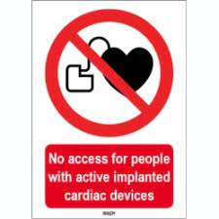 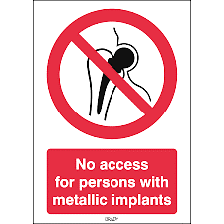

**Figure 10:** Required prohibition signage for areas where magnetic and other electromagnetic fields may be present that could pose a hazard to individuals with specific health conditions / medical implants.

**Inappropriate Signage (Do Not Use)**

It’s worth noting that other types of signage including GHS hazard symbols, CHIP hazard labelling and UN Hazard Class (transport) should not be used to indicate laboratory hazards although it is commonly found in existing working areas. While this type of signage still identifies the hazards present it should not be used in place of the required yellow / black warning signs (see figure 11):

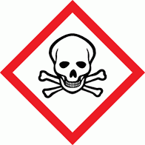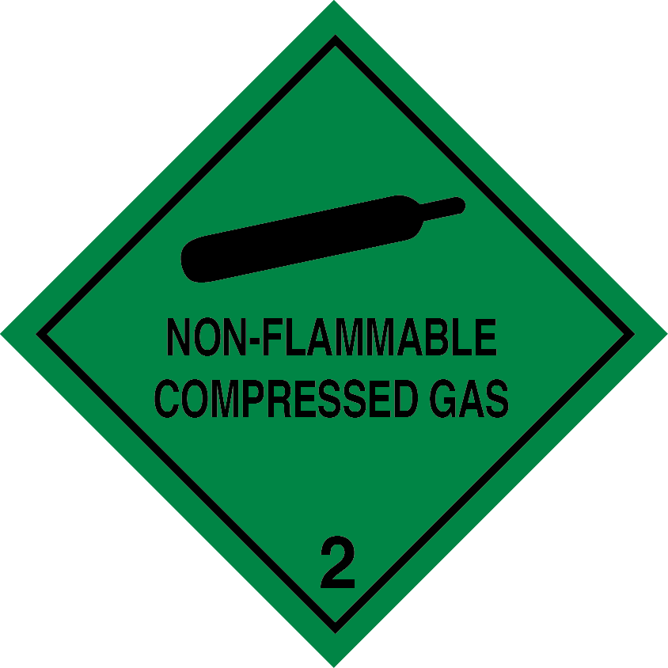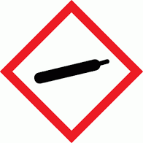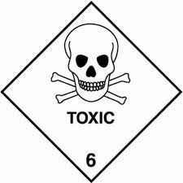

**Figure 11:** The signage above should not be used to indicate laboratory hazards.

**Signage for specific hazard areas**

More detailed signage may be required in specific types of working / storage area including compressed gas cylinder pounds, solvent stores and liquid nitrogen storage / decanting facilities to provide a more detailed indication of the hazards present and actions that may need to be taken (see figure 12 for some examples).

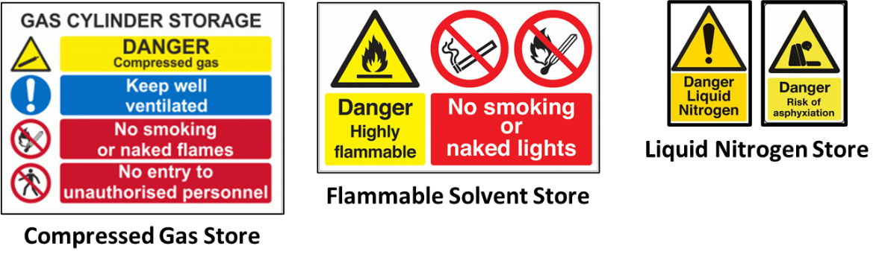

**Figure 12:** Examples of more detailed signage suitable for specific facilities

**Note: Other safety signage / indicators may also be required depending on the hazards present in a given area e.g. emergency response information, ventilation system status, digital readouts associated with gas detection systems etc.**

**Supplementary Information**

It is also recommended that laboratories are fitted (where practical) with a means of displaying more detailed safety information in the vicinity of the entrance door (see figure 13 for an example of one possible solution). Consideration can also be given to the following

* A wall mounted document holder for storing overnight experiment forms and other emergency documentation e.g. laboratory service shutdown procedures, emergency contact lists etc.
* A means of displaying a more detailed breakdown of the safety precautions required and hazards within the working area to support the key hazard information located on the door (see figure 14 for some examples).

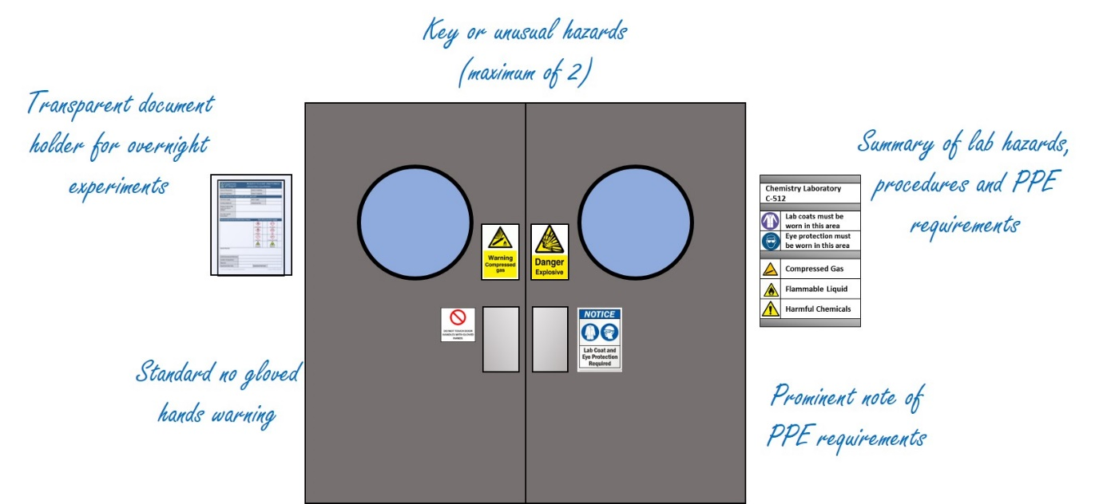

**Figure 13:** Example of laboratory door with document storage and subsidiary hazard information.

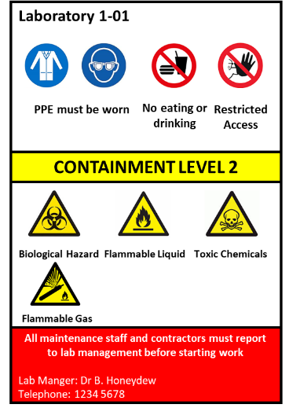 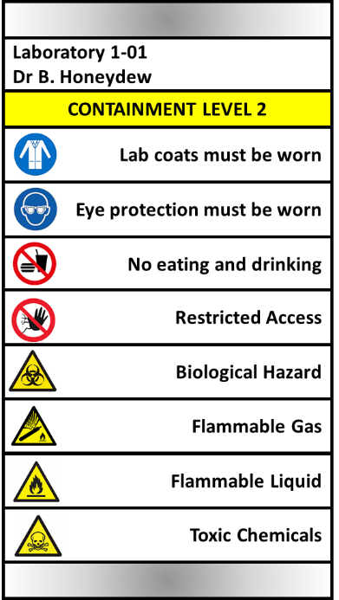

**Figure 14:** Examples of subsidiary hazard information formats (single page printing and sliding bar)