# Accessing XM Basecamp for the first time

* Visit [Qualtrics XM Basecamp](https://basecamp.qualtrics.com/) and select **Log in** from the top right

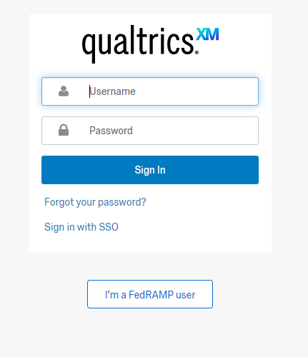

* Select **Sign in with SSO**

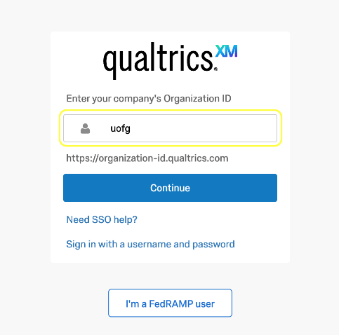

* Enter **uofg** under the **'Organization ID'** field and select **Continue**.

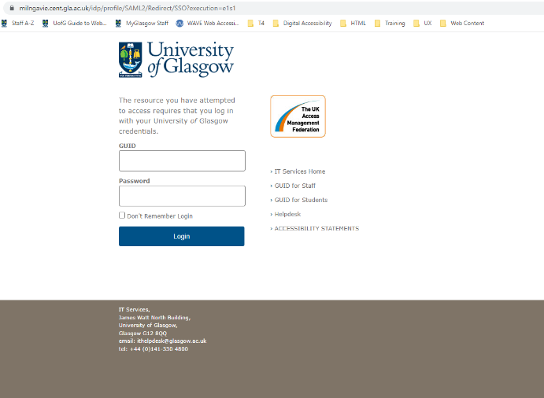

* You’ll be taken to the University of Glasgow login page
* Sign in using your **GUID and password**

2.1  **Ask the XM Community forum**

This is also a forum where you can raise a query or question or conversation topic, not found under the Qualtrics XM support pages. Upon selecting 'Ask the XM Community' on first instance, you will be required to provide further information and agree to the 'Terms of Service'

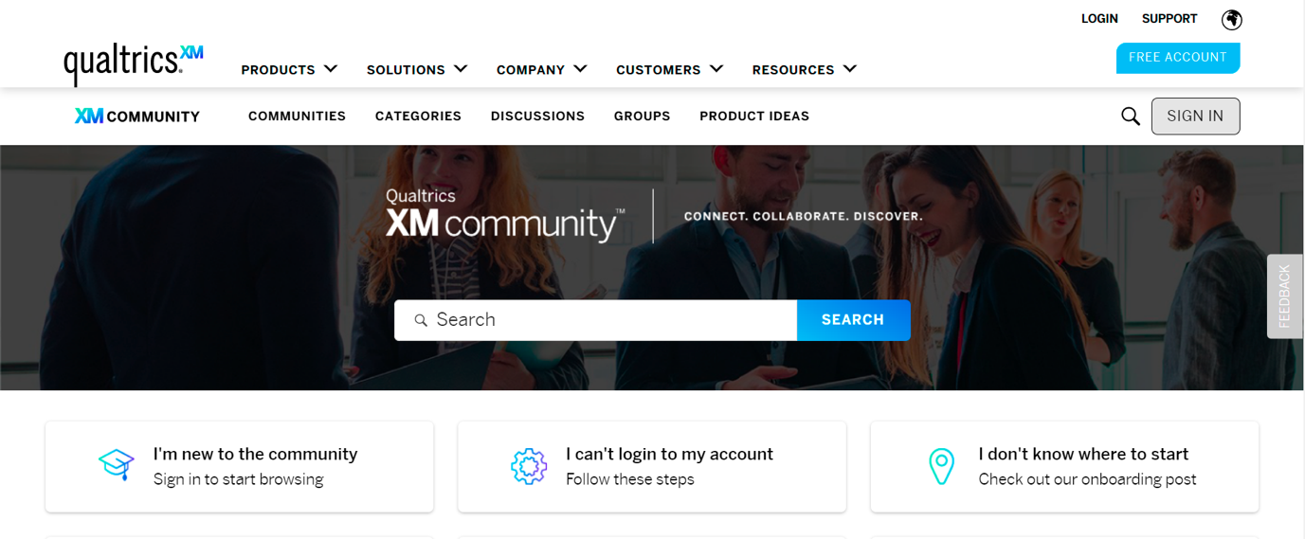

## Contacting Qualtrics Support

In the first instance, please raise your support call via the [UofG Helpdesk](https://www.gla.ac.uk/myglasgow/it/helpdesk/).

If we are unable to help, we will request you raise a support query to Qualtrics XM Support directly by following the instructions below:

* 1. Navigate to the question mark symbol (top right of screen):

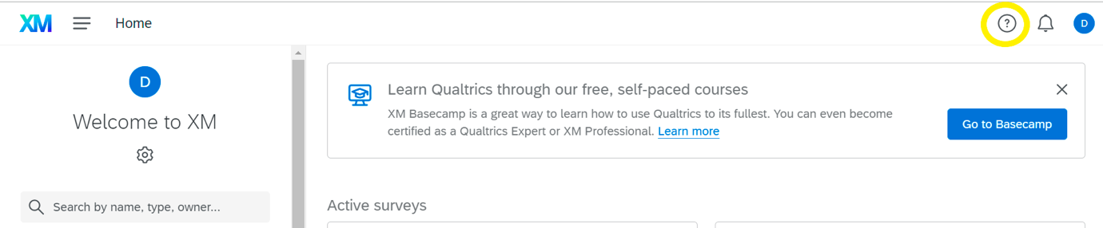

* 1. Select 'Contact Support' link from the new pop up:

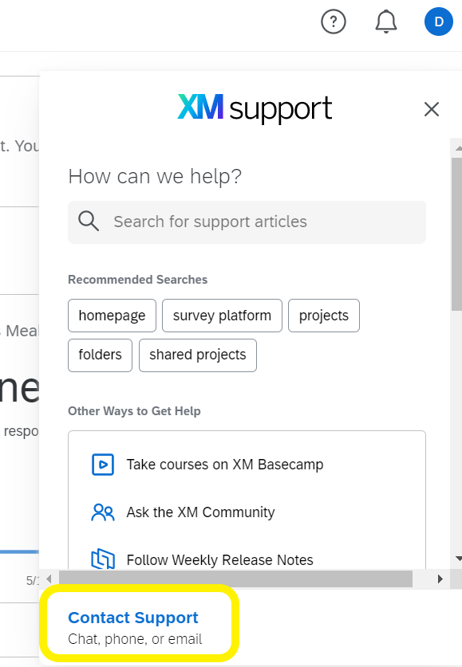

3. 3 Select 'Sign in with SSO':

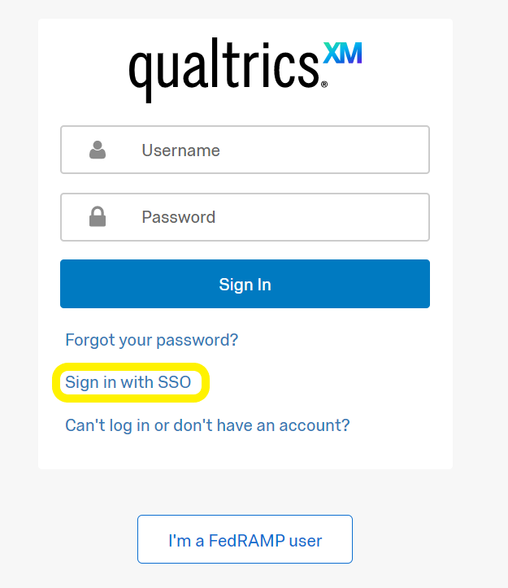

3.4 Enter **uofg** under the 'Organization ID' field below:

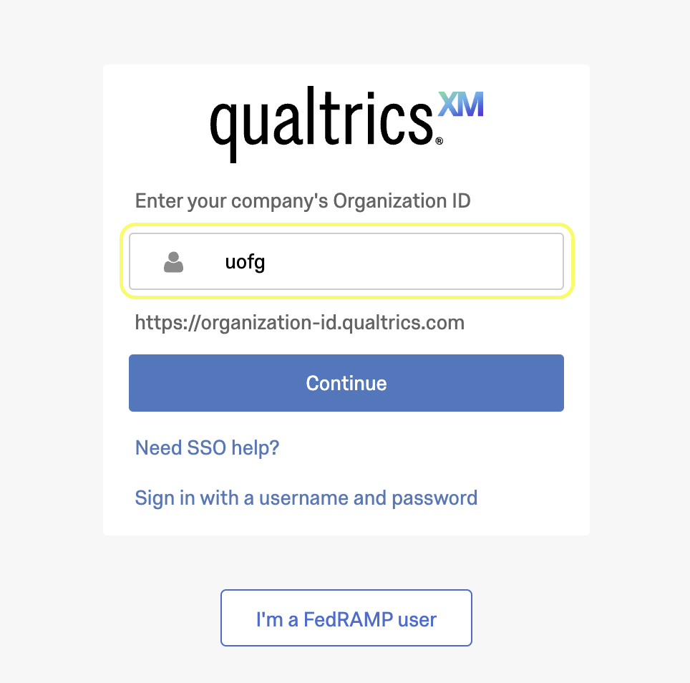

3.5 The Qualtrics XM support webpage should now be presented and you are able to raise support call:

