MyCampus Support, Development & Infrastructure

User Guide
My Campus – Admissions Application Referrals

Document Control
Title: | Admissions Application Referrals
Version: | 1
Owner: | MSDI Admissions
Publication Date: | January 2022
Review Date: | January 2023

Contents

1. Admissions Application Referrals 3
1.1 Add tile to homepage 3
1.2 Referral Assigned – using the UoG pagelet 3
1.3 Review Application – using the UoG Evaluation Summary Page 4
1.4 Process Referral 7
1.4.1 Evaluation Route 1 9
Administrator Steps 9
Supervisor Steps 11
Administrator Steps 14
1.4.2 Evaluation Route 2 19
1.4.3 Evaluation Route 3 20
Selector Steps 20
Refer On Steps 22
A. Appendix: Add Tile to Homepage 24
B. Appendix: Complete Postgraduate research page 25
C. Appendix: Process Flow 26
D. Appendix: Instructions for areas using a group contact email 27
E. Appendix: Notification Sample 28
F. Administrator/contact has changed 29

1. Admissions Application Referrals

Evaluation Route | Career | Process
Route 1 | PGR | Admissions - Admin - Supervisor - Admin - Admissions
Route 2 | UG/PGT | Admissions - Selector - Admissions
Route 3 | UG/PGT/PGR | Admissions - Selector - Refer on - Admissions

Evaluation Route - Further Information

Evaluation Route | Career | When might route be used?
Route 1 | PGR | PGR when Admissions send the application to an admin colleague who will forward on to an appropriate Supervisor to review. The Supervisor then records their decision and returns the application to an admin colleague to complete the referral and return to Admissions.
Route 2 | UG/PGT | Majority of UG/PGT applications. Will be used when Admissions send a referral to an academic for review and academic returns decision to Admissions to be communicated to applicant.
Route 3 | UG/PGT | All Careers, but not used often. This route can be utilised when an application has been sent for review and the Selector requires review by a colleague before a decision can be reached.

1.1 Add tile to homepage

One time set up see appendix A

1.2 Referral Assigned – using the UoG pagelet

Information
Active referrals are assigned to an evaluator and are viewed via a worklist. From here there are different routes the referral may take depending on the type of application and business area. These routes are detailed in step 1.4
For all referrals, a notification will alert the evaluator that a new referral has been received
Referrals should be completed within the pre-determined timescale
Reminder notifications will be sent when the due date has passed

Navigation

Campus Community > Evaluation Management System > Manage Evaluation

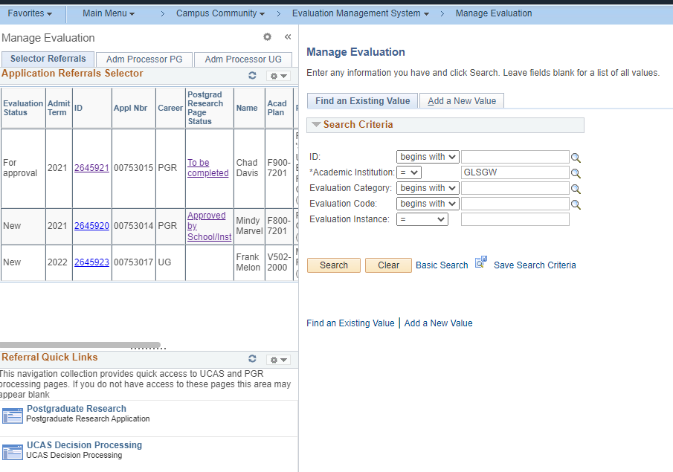

Steps
- Use the Manage Evaluation worklist on the LHS to view and access active referrals assigned to you.
- Use the ID column link on the pagelet to access the referral

1.3 Review Application – using the UoG Evaluation Summary Page

Information
Relevant information for the application can be viewed via the evaluation landing page

Navigation

Campus Community > Evaluation Management System > Manage Evaluation > UoG Evaluation tab

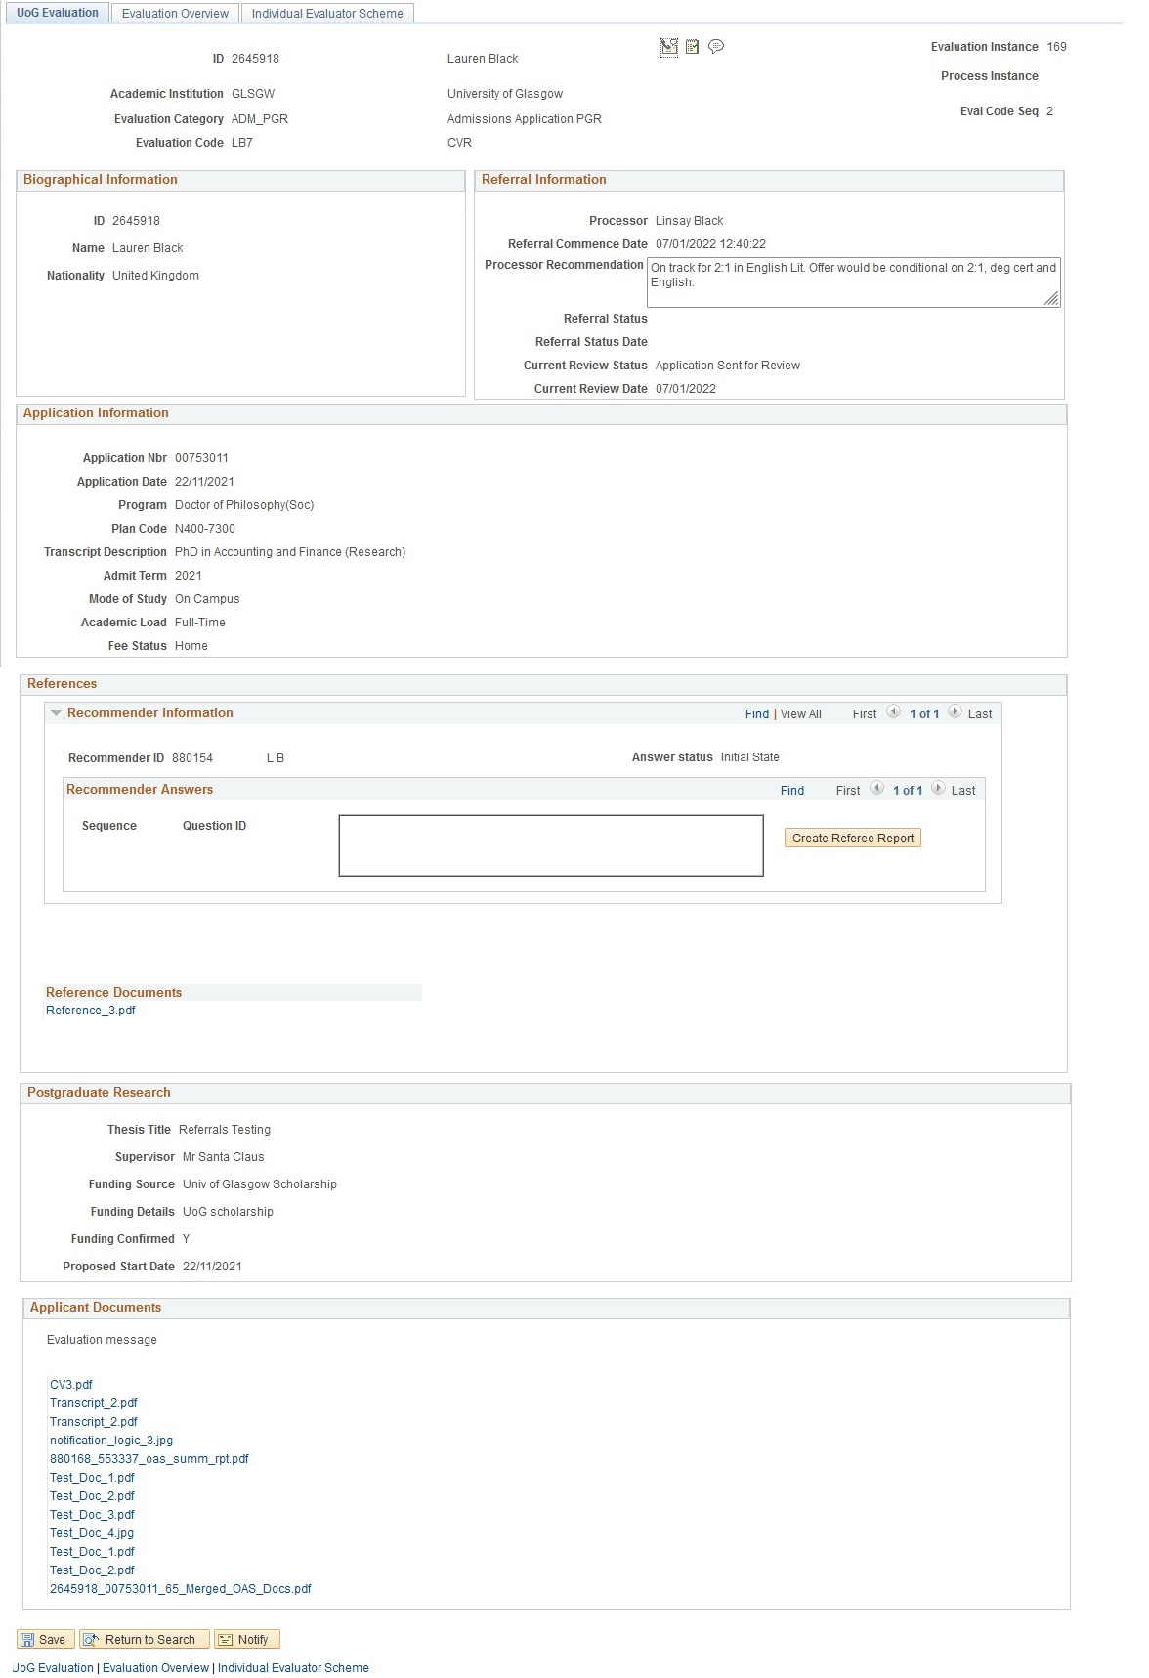

Field | Comments
Biographical Information group box

ID
Name
Nationality
UCAS pers ID
Conditional field
Display only if SCC_GE_XRF_APPL/ACAD_CAREER = ‘UG’

Referral Information group box

Processor
Referral Commence Date
Processor Recommendation
Processor Comments
Remove this field
Referral Status
Referral Status Date
Current Review Status
Current Review Date
Application Information group box

Application Nbr
Application Date
Program
Plan Code
Transcript Description
Admit Term
Mode of Study
Academic Load
Start Duration | Only visible for PGR career
Fee Status
MD Service Indicator | Only visible for UG career
References group box

References can either be an uploaded document or stored as Recommender Answers. Information is displayed here from both sources

Recommender answers
References uploaded documents
Postgraduate Research group box
This group box is only visible for PGR career

Thesis Title
Supervisor
Funding Source
Funding Details
Funding Confirmed
Proposed Start Date
Applicant Documents group box

Each document uploaded to the application is displayed here. Note that password protected documents are not included in the merged document
Click the links to access each document which will open in a new window

1.4 Process Referral

Information

The following outlines the system steps required for each processing route as described above.

Navigation

Campus Community > Evaluation Management System > Manage Evaluation > Individual Evaluator tab

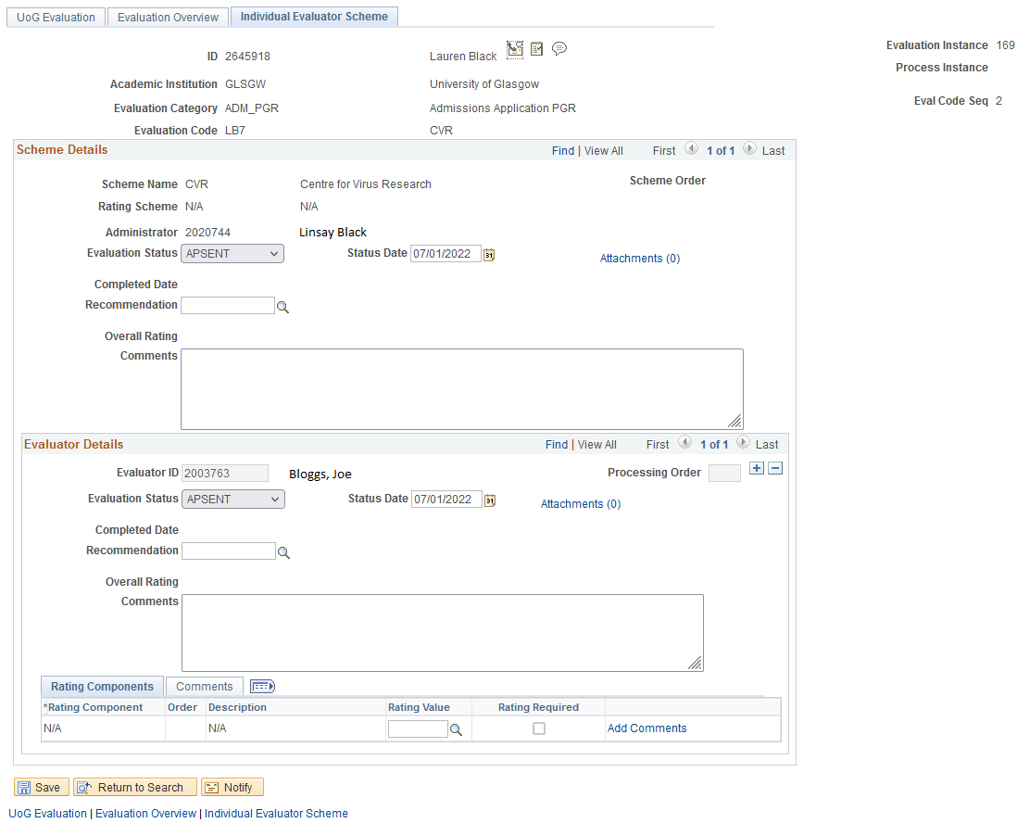

Field | Comments
Scheme Details group box

Evaluator Details group box

Evaluator ID | This should display the ID of the current evaluator (or relevant dummy code if the referral notification is sent to a group email)
Processing Order | This field should be blank
Evaluation Status | The default status is APSENT (application sent for review) and will be updated when each evaluator has completed their review
Status Date | Updates automatically as the Evaluation Status is updated. No need to amend
Completed Date | Read only field populated once the status has been saved to DECRET
Recommendation | The outcome of the application
Overall Rating | Not used at UoG
Comments | Use the comments field to provide additional information for the admissions team
Rating Components | Not used at UoG

1.4.1 Evaluation Route 1

Evaluation Route | Career | Process
Route 2 | PGR | Admissions - Admin - Supervisor - Admin - Admissions

The administrator receiving the evaluation assesses the application and refers on to the appropriate supervisor.
The supervisor makes a decision, the research page is completed and the evaluation is returned to the administrator for sign off.

Administrator Steps

Information
Evaluations at this stage have an Evaluation Status value of ‘New’

- Access and assess the evaluation as per steps 1.2 and 1.3
- Click the + icon to add a new evaluator
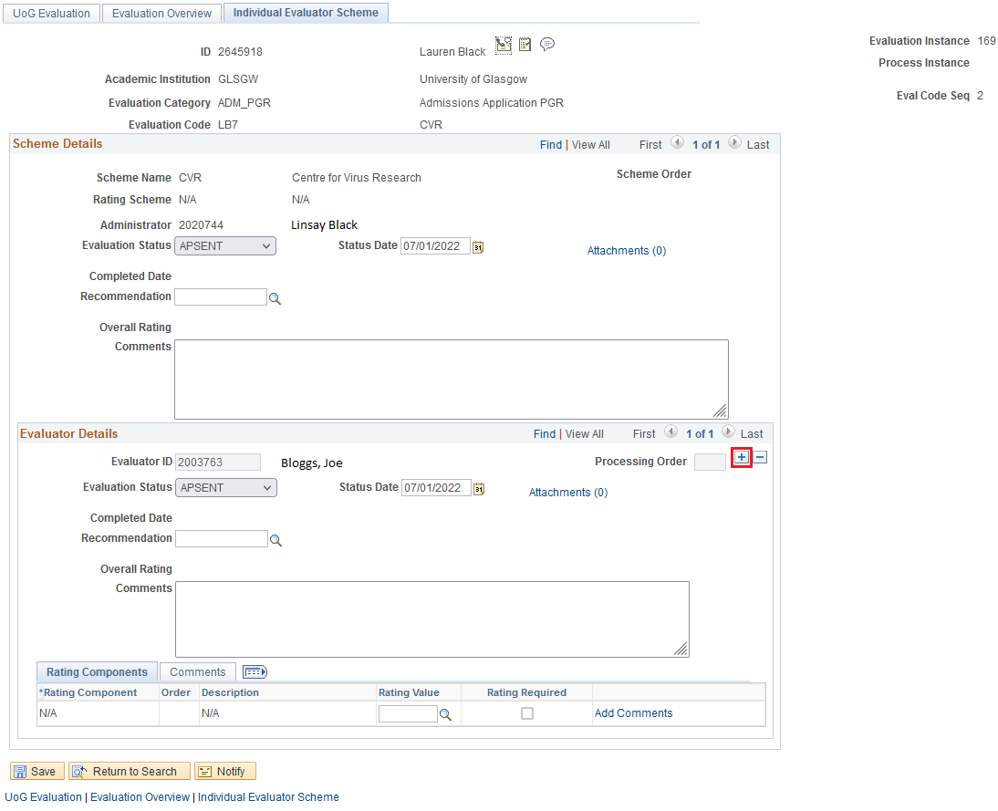

- Use the Evaluator ID look up to search for and select the supervisor
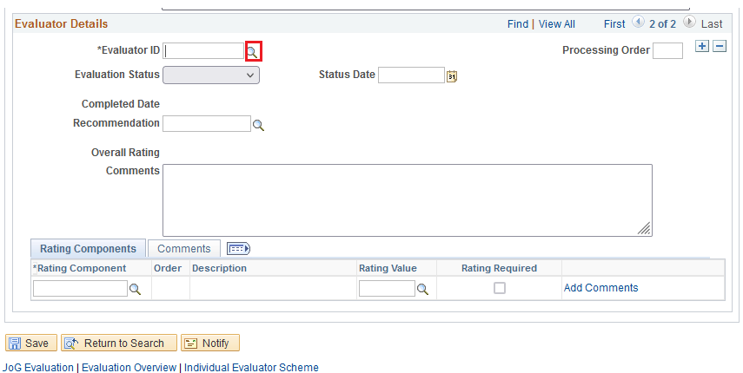
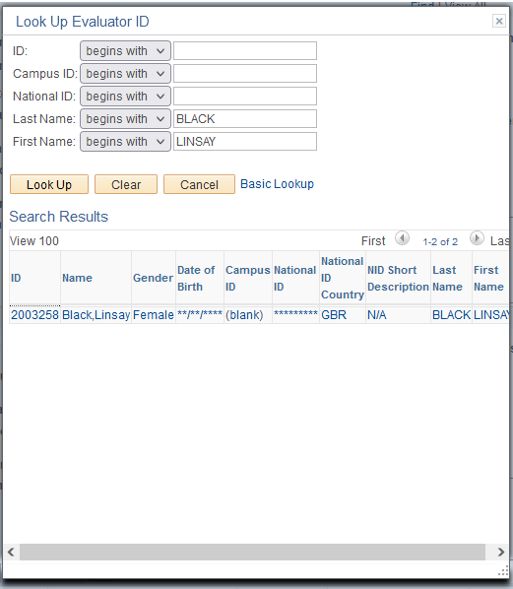

- Set the Evaluation Status to APSENT
- Click SAVE

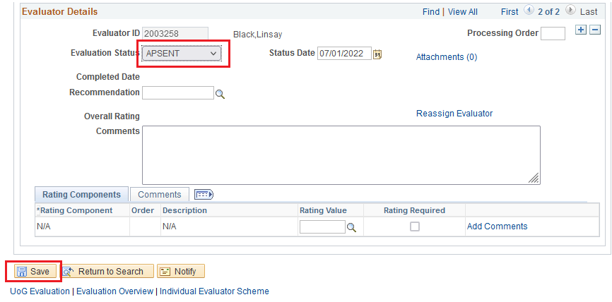

- Go back to the evaluator row assigned to you
- Set Evaluation Status DECRET
- Set Recommendation REFER ON
- SAVE
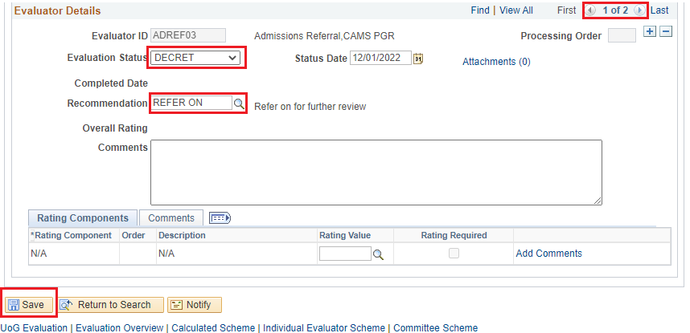

The evaluation has now been reassigned to the supervisor who will receive a notification and see it on their worklist.

Supervisor Steps

- Access and assess the application referral as per steps 1.2 and 1.3

Outcome – Offer

Information
If an offer is being made the Postgraduate Research page must be completed

- Access the Postgraduate Research page via the Postgraduate Research Page Status column on the referrals pagelet. This will open in a new window.

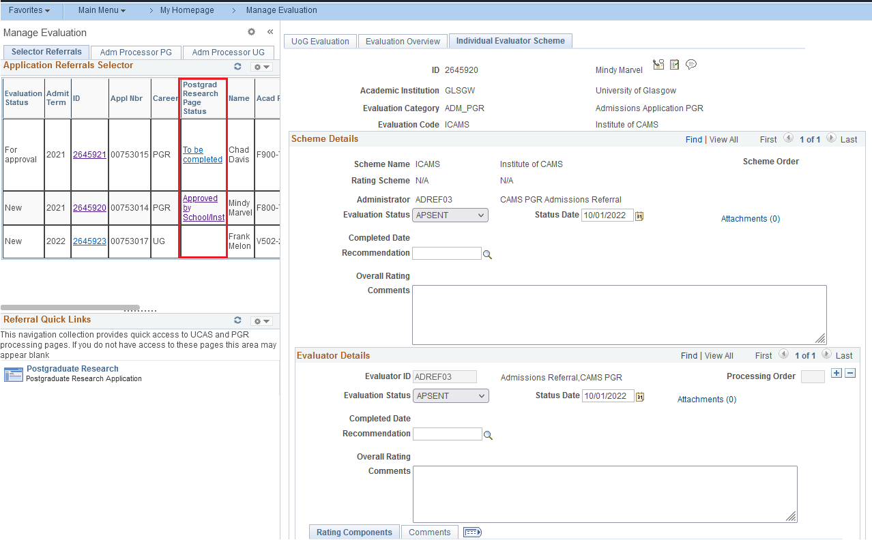

- Complete Research Page (see Appendix B)

- Go back to the evaluation (the browser tab should still be available)
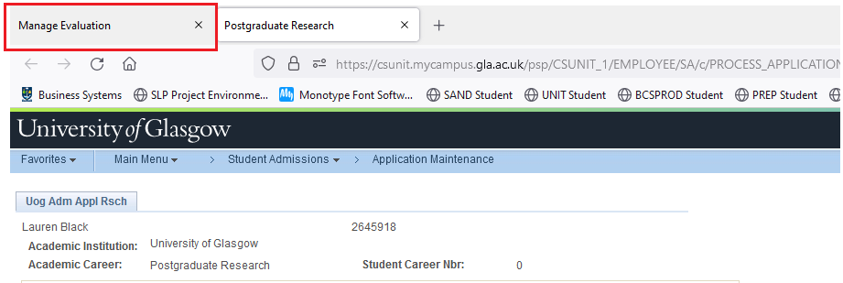

- Enter Evaluation Status DECRET
- Enter Recommendation OFFER

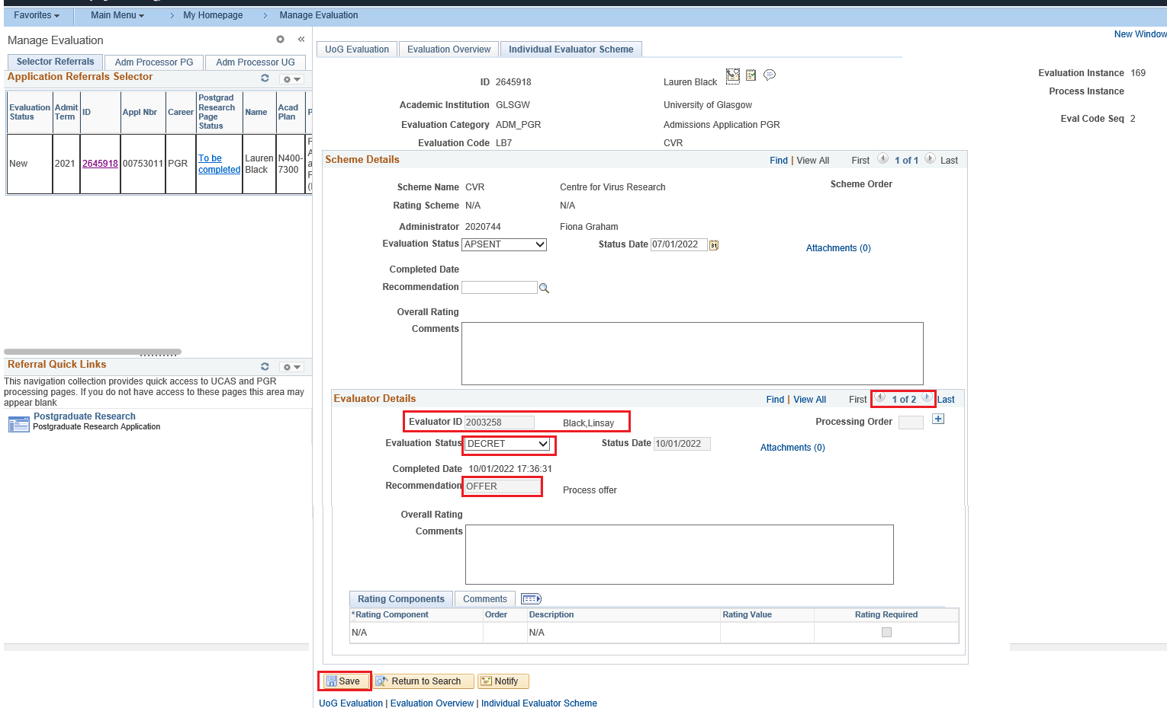

- SAVE

The referral has now been returned to the administrator for final checks

Outcome – Reject

If the application should be rejected,
- Enter Evaluation Status DECRET
- Enter Recommendation - select from the REJ codes
- Enter Comments to provide to provide more information to the administrator
- Click Save

The referral will now be returned to the administrator for final checks

Outcome – Decisions cannot be made without further documentation from the applicant

- Enter Evaluation Status DECRET
- Enter Recommendation DOCSREQUIR
- Enter Comments to provide additional information to the administrator e.g. which documents should be requested form the applicant
- Save

The referral will now be returned to the administrator for final checks

Administrator Steps

Information
Evaluations at this stage have an Evaluation Status value of ‘For approval’

- Access the referral as per step 1.2
- Find the supervisors recommendation in the Evaluator Details section
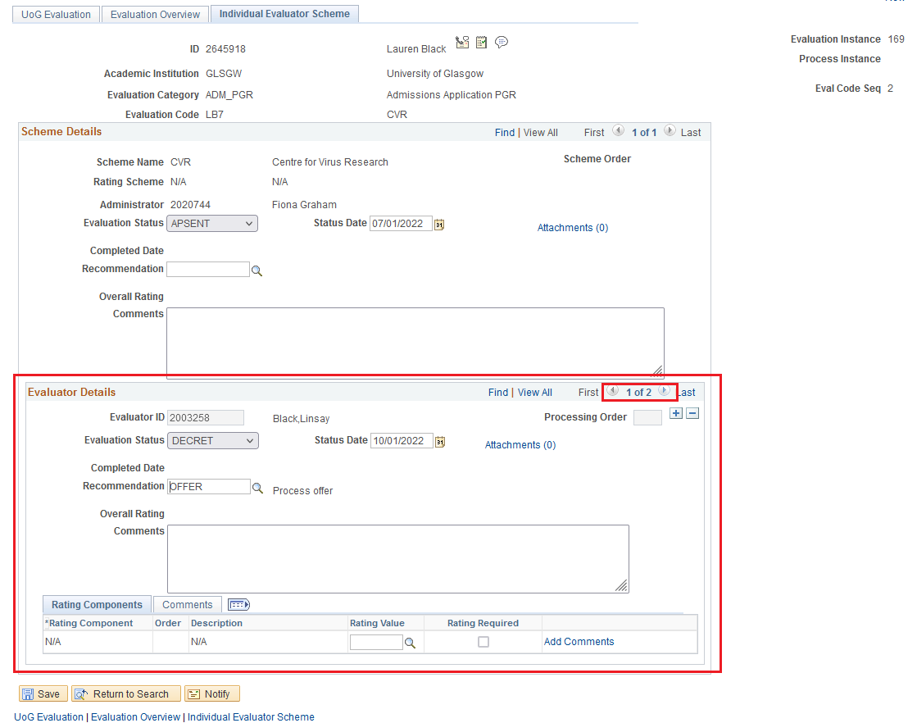

Outcome - Offer

Information
To complete the evaluation, the Postgraduate Research page must be completed AND Scheme Details must be completed by copying over the details entered by the supervisor

Steps
- Access and check the Postgraduate Research page via the Postgraduate Research Page Status column on the referrals pagelet. This will open in a new window.

- Confirm the PGR details See Appendix B for more information
- Go back to the evaluation
- Enter Evaluation Status DECRET
- Enter Recommendation OFFER
- Save

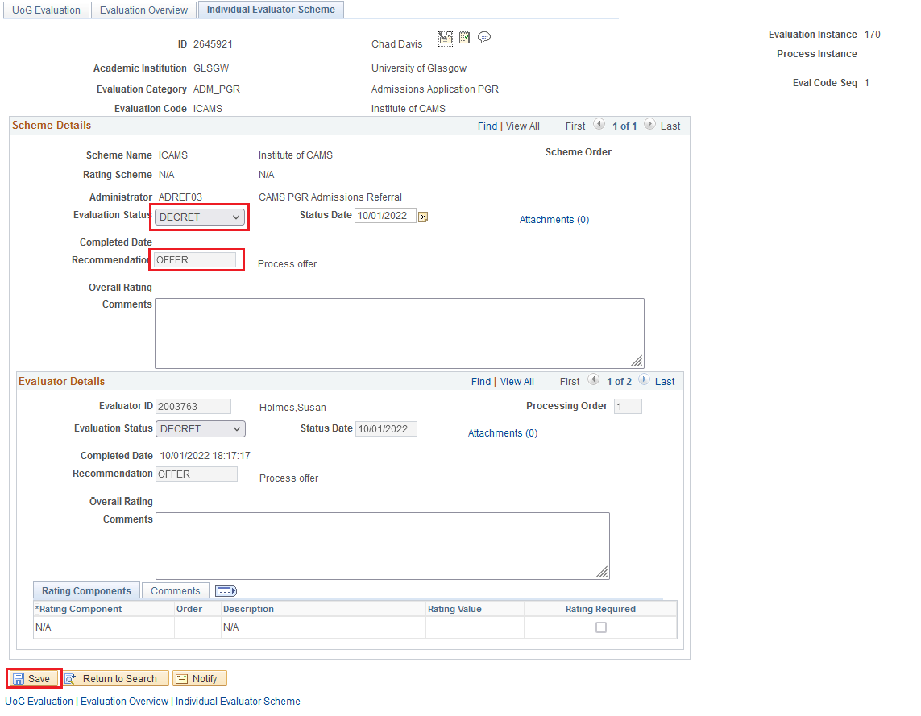

The referral has now been completed and has been returned to Admissions for processing

Outcome – Reject

To complete the evaluation, Scheme Details must be completed by copying over the details entered by the supervisor
- Enter Evaluation Status DECRET
- Enter Recommendation select from the REJ codes
- Enter Comments to provide additional information to admissions if required
- Save
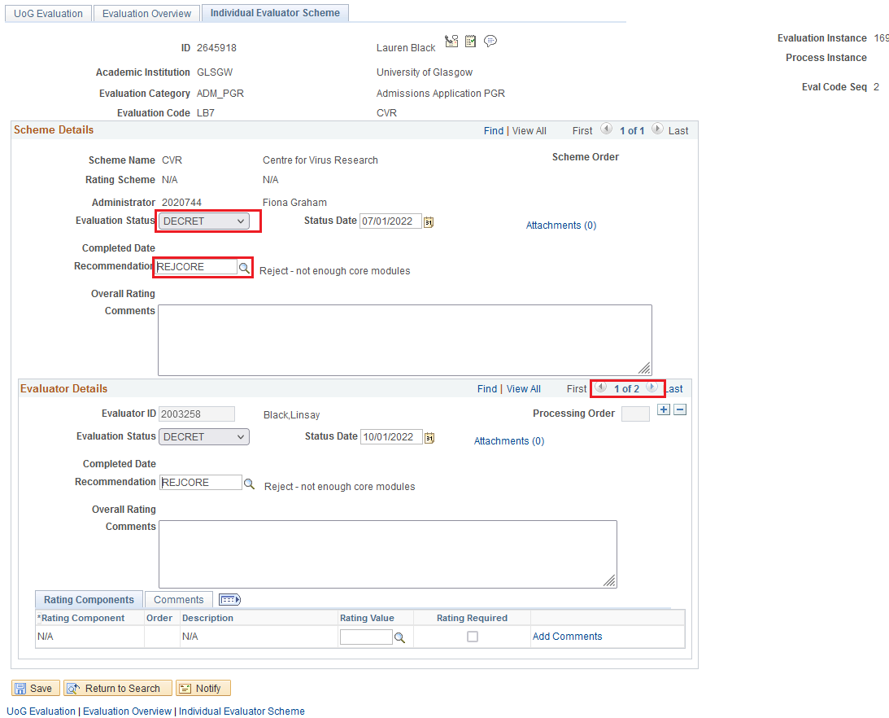

The referral has now been completed and has been returned to Admissions for processing

Outcome – Decisions cannot be made without further documentation from the applicant

Information
To complete the evaluation, Scheme Details must be completed by copying over the details entered by the supervisor

- Enter Evaluation Status DECRET
- Enter Recommendation DOCSREQUIR
- Enter Comments to provide additional information to admissions if required (comments need only be entered once on the Evaluator Details section)
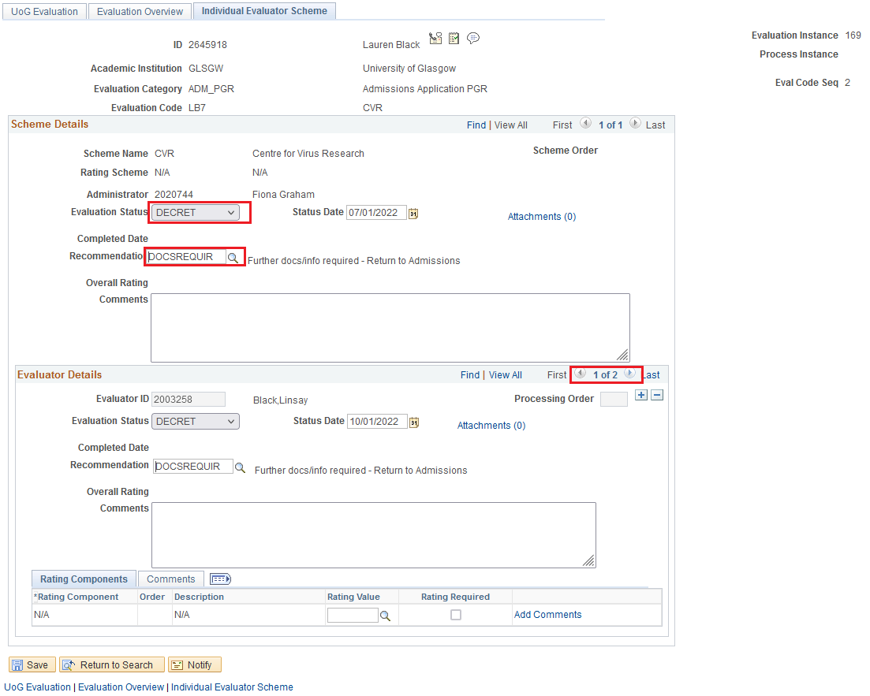

The referral is now complete and has been returned to Admissions for processing. When the relevant documents have been received from the applicant, a new referral will be created by the admissions team.

1.4.2 Evaluation Route 2

The selector receiving the evaluation has decision making power and can complete the referral without sending on to another colleague

Evaluation Route | Career | Process
Route 3 | UG/PGT | Admissions - Selector - Admissions

Steps

- Enter the Evaluation Status to DECRET (decision returned)
- Enter the Recommendation

If the application should be made an offer select OFFER
If the application should be rejected select from the REJ codes to provide more information to admissions
If a decision cannot be reached as further documents are required select DOCSREQUIR

- Enter Comments to provide additional information to admissions if required
- Click Save

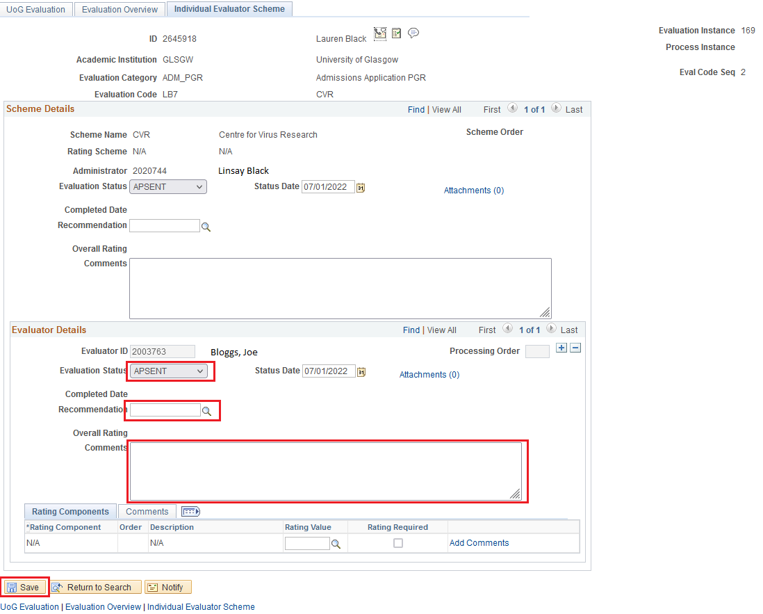

The referral will now be returned to admissions for further processing

1.4.3 Evaluation Route 3

The selector receiving the evaluation assesses the application and refers on to the appropriate member of staff who completes the evaluation

Evaluation Route | Career | Process
Route 4 | UG/PGT/PGR | Admissions - Selector - Refer on - Admissions

Selector Steps

- Click the + icon to add a new evaluator

- Use the Evaluator ID look up to search for and select the relevant ID

- Set the Evaluation Status to APSENT
- Click SAVE
- Go back to the evaluator row assigned to you
- Set Evaluation Status DECRET (Decision returned)
- Set Recommendation SUPERVISOR (Sent to Supervisor)
- Save

The evaluation has now been reassigned to the supervisor who will receive a notification and see it on their worklist.

Refer On Steps

- Access and assess the application referral as per steps 1.2 and 1.3

To complete the evaluation both Evaluator Details and Scheme Details must be completed
- Enter Evaluation Status DECRET
- Enter Recommendation

If the application should be made an offer select OFFER
If the application should be rejected select from the REJ codes to provide more information to admissions
If a decision cannot be reached as further documents are required select DOCSREQUIR

- Enter Comments to provide additional information to admissions if required (comments need only be entered once on the Evaluator Details section)

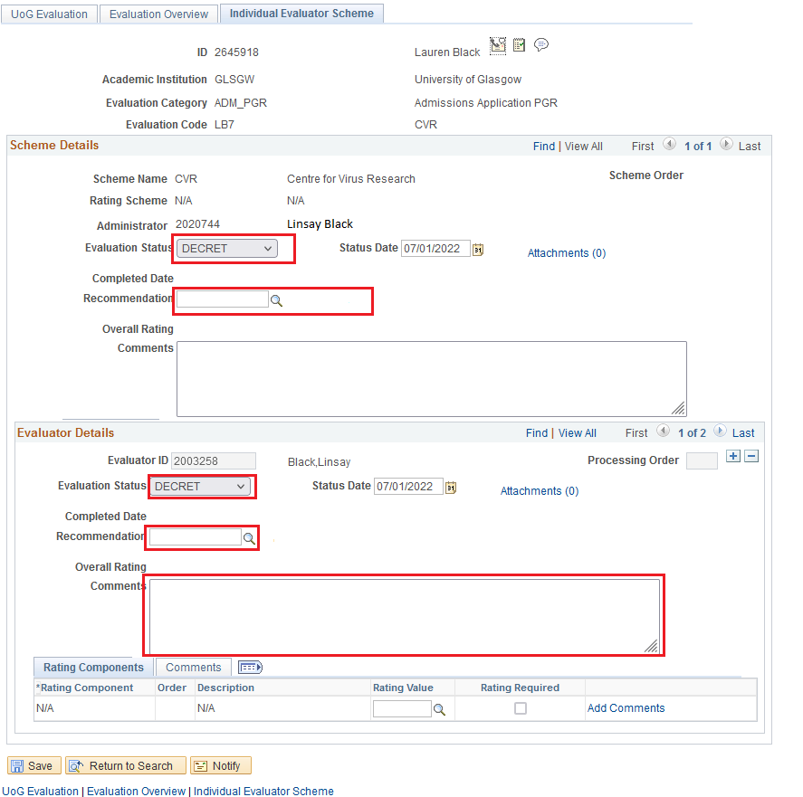
- SAVE

The referral has now been completed and has been returned to Admissions for processing

- Appendix: Add Tile to Homepage

Information

To provide quick access to referrals, the Manage Evaluation page can be added as a homepage tile. The following steps need to be completed once

Navigation

Nav: Campus Community > Evaluation Management System > Manage Evaluation

Steps
- From the menus bar select Add to Homepage

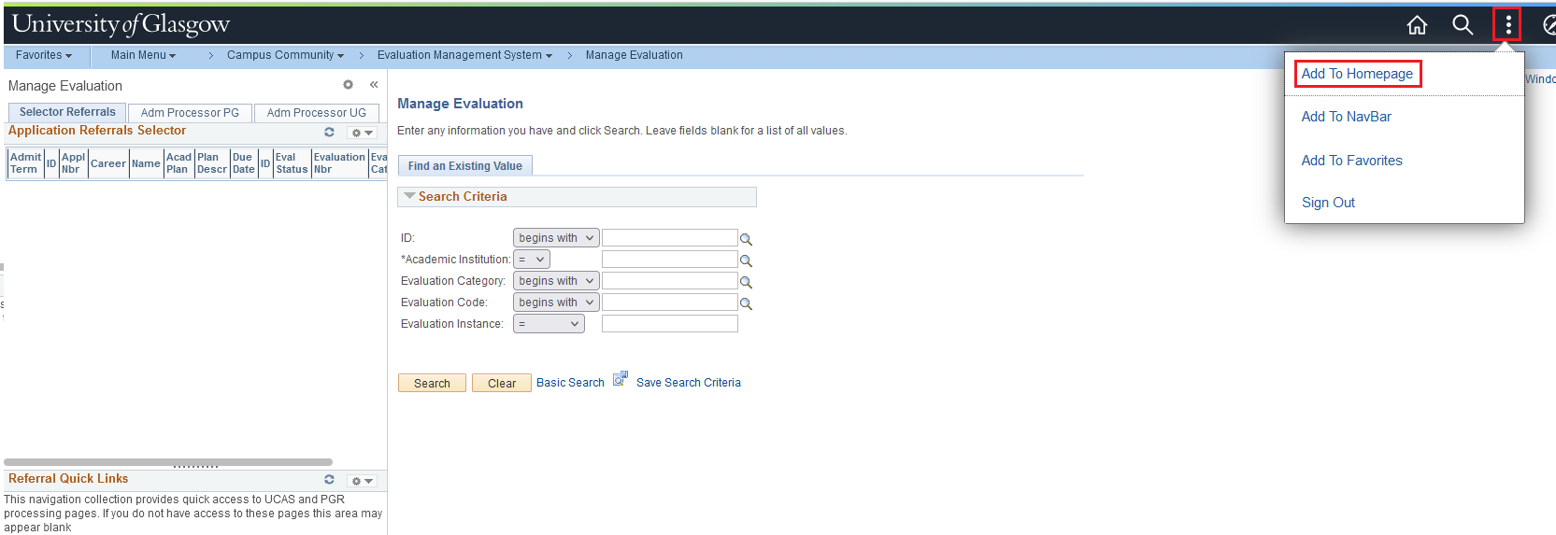

- Select My Homepage

- View the message and click OK
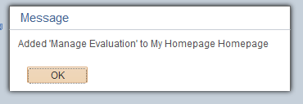

- Click on the Home icon

- Manage Evaluation is now available as a quick link/tile

Appendix: Complete Postgraduate research page

Details to be completed

- Start Date
- Research Title
- Abstract 5-6 line approx. (if International and require ATAS)

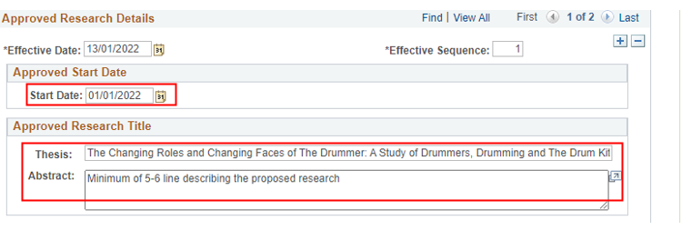
- Supervisor Details – Use the look up to find the Supervisor name. Click + button to add additional Supervisors
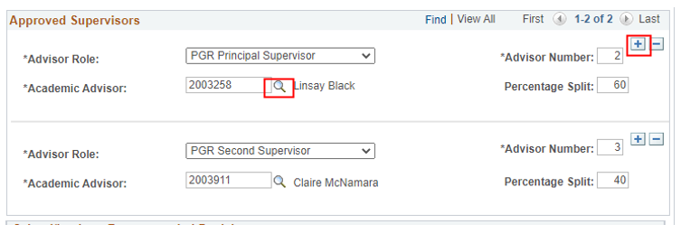

Approval Information

- Approval Status should be: Recommended by School (Supervisor) or Approved by School (Administrator)
- Decision i.e. Unconditional/Conditional
- Bench Fees (if applicable)

In comments box:
- CAH3 code (if International and require ATAS) (previously JACS code)
- Any other details i.e. conditions of offer, part-time etc.

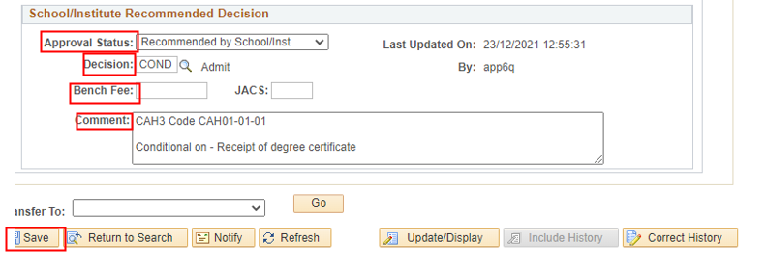
Then click Save button
- Appendix: Process Flow

In progress.
- Appendix: Instructions for areas using a group contact email

Process to be confirmed prior to implementation.

- Appendix: Notification Sample

- Administrator/contact has changed

Process to be confirmed prior to implementation.

