MyCampus Support, Development & Infrastructure

User Guide
My Campus – Postgraduate Research Admissions Referrals Quick Guide for Academics

Document Control
Title: | Admissions Application Referrals
Version: | 1
Owner: | Admissions
Publication Date: | June 2022
Review Date: | June 2023

Contents

1. Admissions Application Referrals 3
1.1 Add tile to homepage 3
1.2 Review Application – using the UoG Evaluation Summary Page 3
1.3 Evaluation 4
Final Decision 4
Refer on steps 5
A. Appendix: Add Tile to Homepage 9
B. Appendix: Notification Sample 9
C. Appendix: Troubleshooting 10

1. Admissions Application Referrals

1.1 Add tile to homepage

One time set up see appendix A

1.2 Review Application – using the UoG Evaluation Summary Page

Information
Relevant information for the application can be viewed via the evaluation landing page

Navigation

Campus Community > Evaluation Management System > Manage Evaluation > UoG Evaluation tab

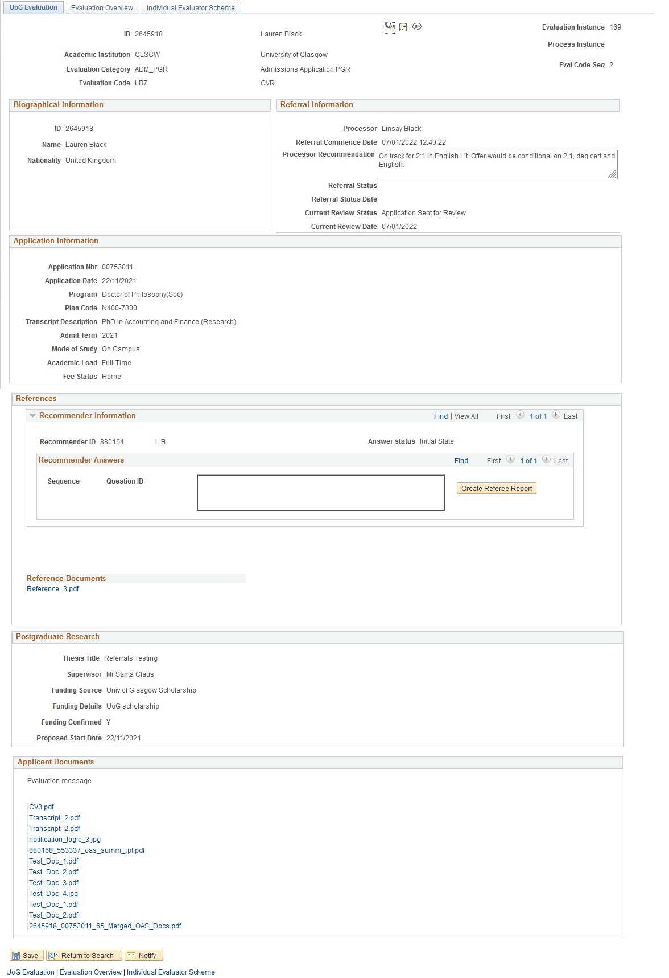

1.3 Evaluation

The administrator has referred the application on for decision. (note you can refer on the application to as many staff members as required). (see Refer on steps) You will receive an email notification email (see appendix B) Click on the Evaluation worklist link and this will take you to the application for review.

Final Decision

- Access and assess the application referral as per steps 1.2 and 1.3

Outcome – Offer

Information

- Enter Evaluation Status DECRET (Decision made or refer on)
- Enter Recommendation OFFER

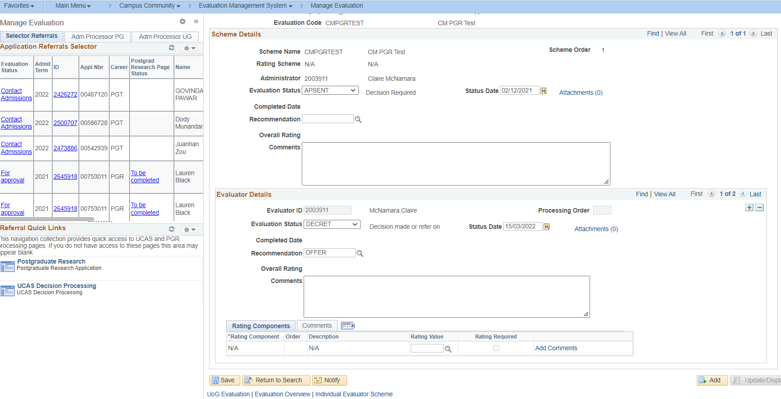

- SAVE

The referral has now been returned to the administrator for final checks

Outcome – Reject

If the application should be rejected,
- Enter Evaluation Status DECRET (Decision made or refer on)
- Enter Recommendation - select from the REJ codes
- Enter Comments to provide to provide more information to the administrator
- Click Save

The referral will now be returned to the administrator for final checks

Outcome – Decision cannot be made without further documentation from the applicant

- Enter Evaluation Status DECRET (Decision made or refer on)
- Enter Recommendation DOCSREQUIR
- Enter Comments to provide additional information to the administrator e.g. which documents should be requested form the applicant
- Save

The referral will now be returned to the administrator for final checks

Outcome – Decision cannot be made, in discussion with the applicant

- Enter Evaluation Status ONHOLD (in contact with Applicant)
- Enter Comments to provide additional information to the administrator e.g. in discussion with applicant regarding changes to research proposal
- Save

The referral will now sit with the member of staff who put it on hold. Once ready to make a decision follow the steps above.

Outcome – Interview Applicant

- Enter Evaluation Status INTERV (interview on hold)
- Save

The referral will now sit with the member of staff who put it on hold. Once ready to make a decision follow the steps above.

Outcome – Scholarship - Hold

- Enter Evaluation Status SCHOLA (Scholarship - on hold)
- Save

The referral will now sit with the member of staff who put it on hold. Once ready to make a decision follow the steps above.

Refer on steps

- Access and assess the evaluation as per steps 1.2 and 1.3
- Click the + icon to add a new evaluator

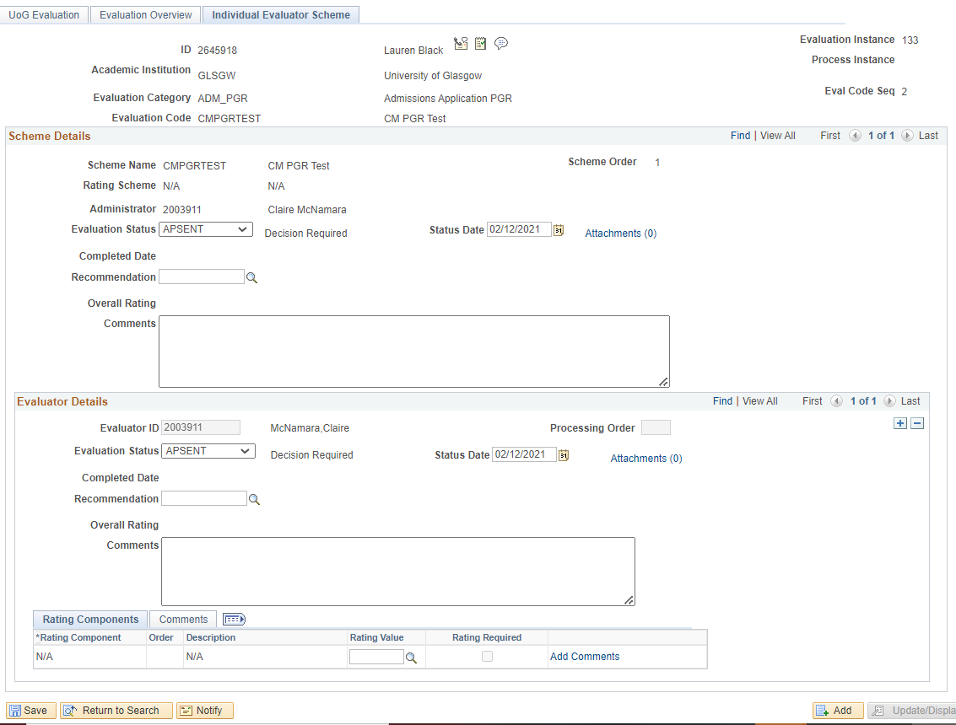

- Use the Evaluator ID look up to search for and select the relevant ID
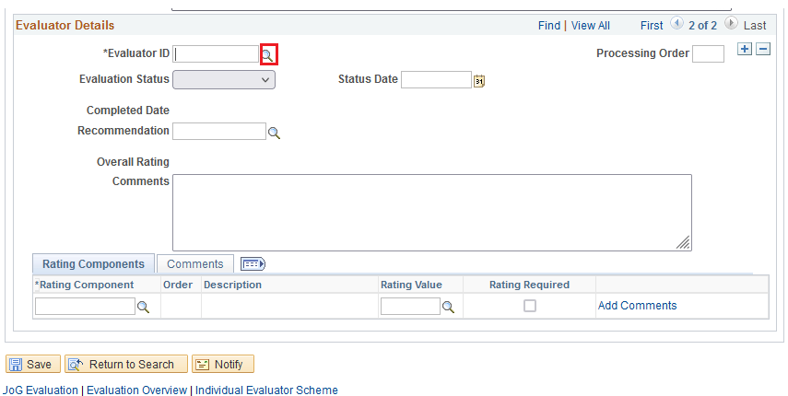
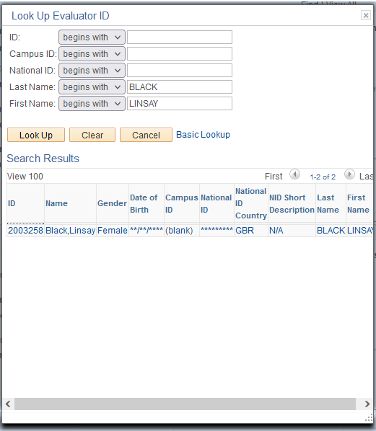

- Set the Evaluation Status to APSENT
- Click SAVE
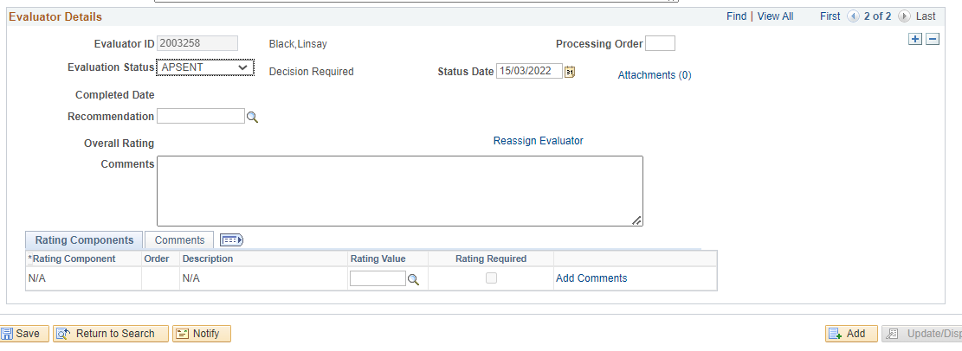
- Go back to the evaluator row assigned to you
- Set Evaluation Status DECRET (Decision made or refer on)
- Set Recommendation REFER ON (Refer on for further review)
- SAVE
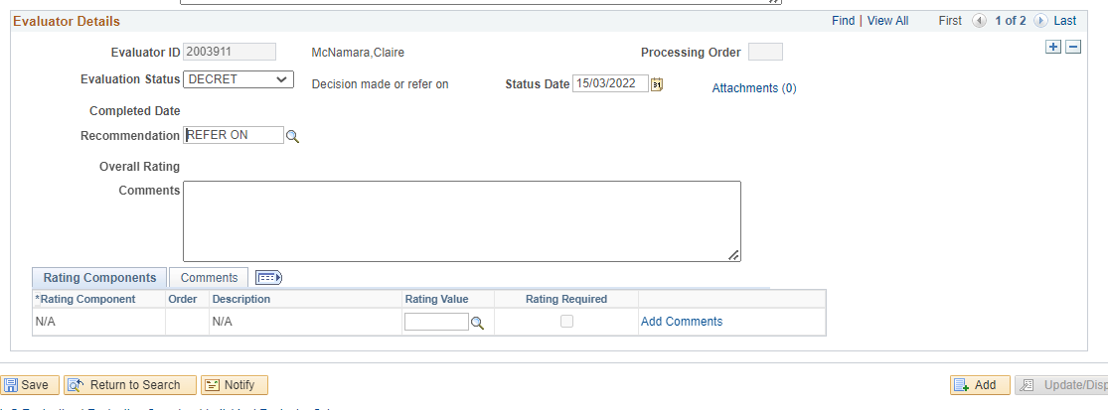

The evaluation has now been reassigned to the next member of staff who will receive a notification and see it on their worklist.

You can repeat the Refer On steps as many times as required, until a final decision has been reached.

- Appendix: Add Tile to Homepage

Information

To provide quick access to referrals, the Manage Evaluation page can be added as a homepage tile. The following steps need to be completed once

Navigation

Nav: Campus Community > Evaluation Management System > Manage Evaluation

Steps
- From the menus bar select Add to Homepage

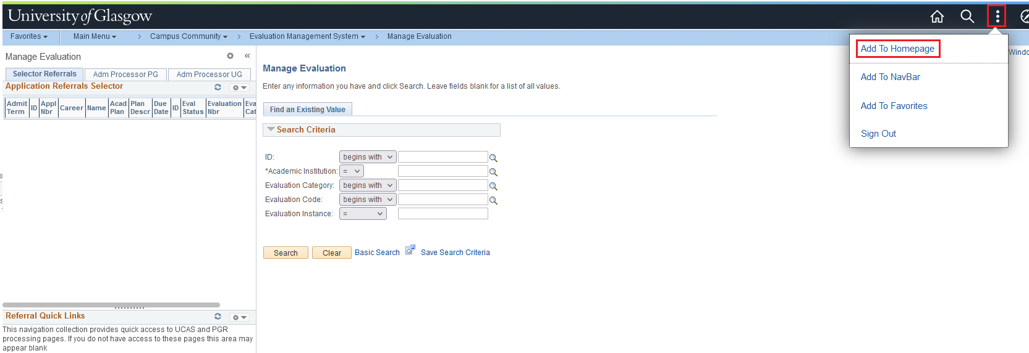

- Select My Homepage

- View the message and click OK

- Click on the Home icon

- Manage Evaluation is now available as a quick link/tile
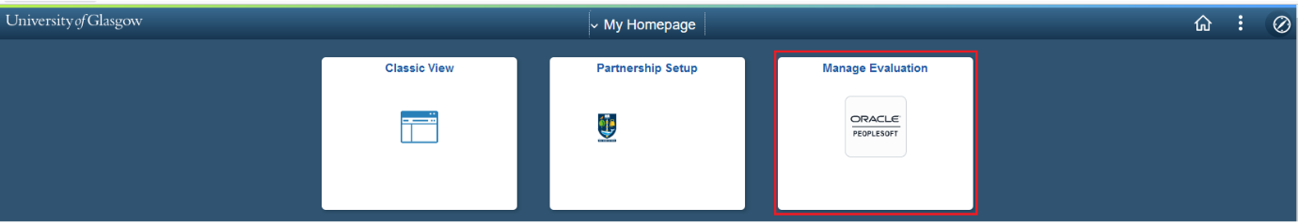

- Appendix: Notification Sample

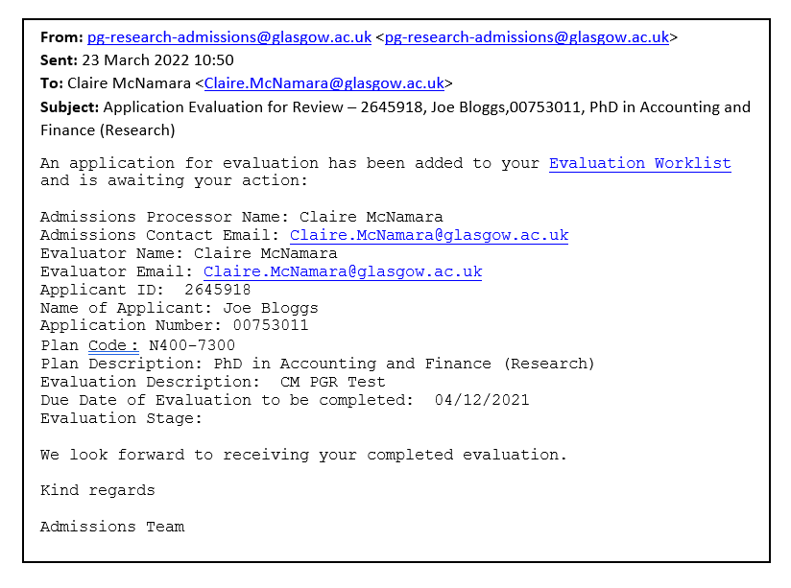

- Appendix: Troubleshooting

Information

If you have any questions/issues you can contact the Admissions Team via the Teams channel and one of the Admissions team will respond. If you do not have access to the Teams Channel – please contact Lynn D’Adamo – Lynn.D’Adamo@glasgow.ac.uk to provide access.

College Team Channels

College of Arts – Referral Processing Troubleshooting
College of MVLS – Referral Processing Troubleshooting
CoSE – Referral Processing Troubleshooting
CoSS – Referral Processing Troubleshooting

Log in error

If you get an error when logging in to MyCampus, please upload a screenshot of the error to Teams

Referral Completed in Error

Please provide student ID and application number and Admissions will hold the offer and re-open the referral.

