(The College/School logo must be used unless the Ethics Committee specifically permits you not to.)
This is a sample of an easy read Plain Language Statement, which could be used for children or those requiring a simplified version. It is suggested that you use at least font size 14.
(Remove blue text - Use the clauses appropriate to your needs)

Invitation to take part in a project

My name is ……………………………… and I am a researcher at the University of Glasgow.
You could use a photo of yourself here or a drawing.

I would like to hear what you think about
………………………………………………………………
Explain in simple terms what you want to talk about.

I would like to meet you to have a chat about this.

We can meet in your home or somewhere else.

I would like to record our chat so I can remember what we all said. Remember that you must have permission from them to record.

You do not need to answer any questions that you do not want to.

This will help me to find out
…………………………………………………………………………..
…………………………………………………………………………..
Use your own picture that relates to your research and explain in simple terms what the purpose of your research is.
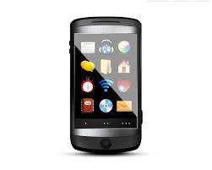
If you would like to talk to me about this project you can call or text me on …………………………………..

Or email me at …………………@..........................

Thank you.

End ______________________________________________________

