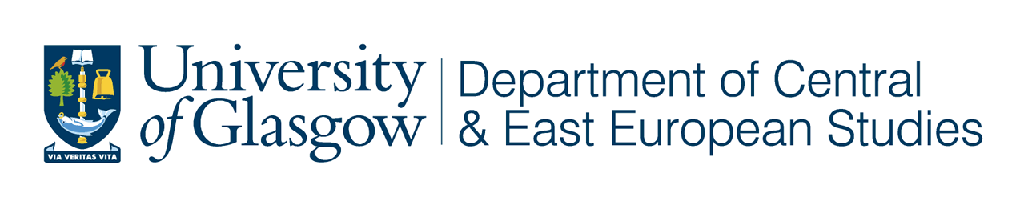

Remembering 1948 and 1968: Reflections on Two Pivotal Years in Czech and Slovak History

University of Glasgow, 3 – 4 April 2008

This conference to commemorate the 60th anniversary of the imposition of communism in Czechoslovakia and the 40th anniversary of the Prague Spring has been organised by the Department of Central and East European Studies in conjunction with the wider CRCEES network. This conference will reflect upon the impact of these momentous events on Czech and Slovak society, culture and politics. New research by scholars based in the Czech Republic and Slovakia will be presented alongside that of UK and other international scholars. The conference will address new perspectives on these historical events and how they are remembered, reflect on their international significance and challenge the myths which have grown up around them.

Key Speakers:

Antonin J. Liehm,
Founder of Lettres Internationales and the editor of Listy and 150 000 slov.

Vilém Prečan,
Historian and Author of "Seven Prague Days" (The Prague Black Book),

Václav Žák,
Head of the regulatory Council for Radio and Television Broadcasting and Editor in Chief of the political bimonthly Listy.

Other confirmed speakers:
Kevin Adamson, Petr Bílek, Daniel Bird, Muriel Blaive, Maud Bracke, Scott Brown, Eva Cermanova, Jan Čulík, Marta Filipová, Jana Fischerova, Roger Gough, Erika Harris, Mary Heimann, Juraj Marušiak, Kevin McDermott, Martin Myant, Libora Oates-Indruchova, Vladimír Papoušek, Charles Sabatos, Štěpán Strnad, Geoffrey Swain, Aviezer Tucker, Veronika Tuckerova and Deanna Wooley.

The conference fee will be £25 per day (£15 per day for students). This includes registration, coffee/tea and lunch.

For further information contact Dr Laura Cashman l.cashman@lbss.gla.ac.uk


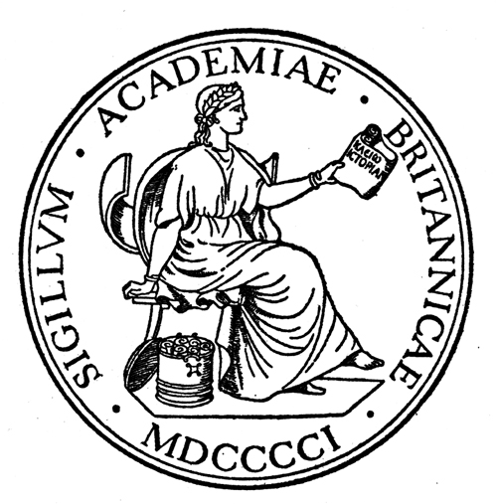


Remembering 1948 and 1968: Reflections on Two Pivotal Years in Czech and Slovak History

University of Glasgow, 3 – 4 April 2008

Conference Registration Form

Name: ---------------------------------------------------------------------------------------------------

Institution: ---------------------------------------------------------------------------------------------------

Address: ---------------------------------------------------------------------------------------------------

---------------------------------------------------------------------------------------------------

Email: ---------------------------------------------------------------------------------------------------

Fee payable: (registration, tea/coffee and lunch)

□ Academic/ Full time employment £25 per day
□ Student £15 per day

Please indicate special dietary requirements: -----------------------------------------------------------

Do you expect to attend the Alexander Lazarev Lecture on 2 April? Y / N

Please make your cheque payable to ‘The University of Glasgow’ and return no later than Wednesday, 28 March to:

DR LAURA CASHMAN
DEPARTMENT OF CENTRAL AND EAST EUROPEAN STUDIES
UNIVERSITY OF GLASGOW
HETHERINGTON BUILDING
BUTE GARDENS
GLASGOW G12 8RS

Tel: 0141 330 6039
Email: l.cashman@lbss.gla.ac.uk

