Risk assessment guidelines:

- Risk assessments should be submitted for review at least 1 week before activity is planned.
- If risk assessment or risk mitigation is deemed inadequate the activity will not be allowed to proceed until an updated risk assessment is received and approved.
Risk associated with all aspects of the activity should be calculated with reference to the tables below:

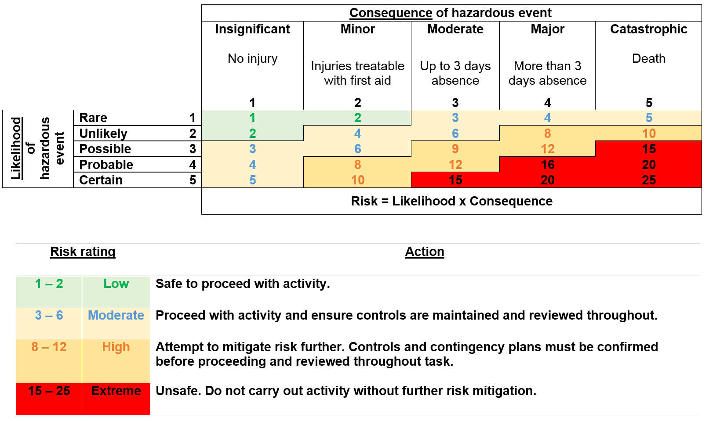
Risk rating = Likelihood x Consequence

- Any activities deemed High or Extreme risk should not take place without further risk mitigation.
- Any questions, contact Michael Muir: Michael.Muir@glasgow.ac.uk

Title of activity: | Click here to enter text.
Location: | Click here to enter text.
Duration: | From: | Click here to enter a date. | To: | Click here to enter a date.
Description of activity, including brief itinerary: | Click here to enter text.
Assessed by: | Click here to enter text.

People involved in the activity:
 | Names | Mobile number | First-aider?
Activity leaders: | Click here to enter text. | Click here to enter text. | Click here to enter text.
Assistants: | Click here to enter text. | Click here to enter text. | Click here to enter text.
 | Number of students
Undergraduate students | Click here to enter text.
Postgraduate students | Click here to enter text.

Other organisations involved | Name and contact details of person within organisation
Click here to enter text. | Click here to enter text.
Click here to enter text. | Click here to enter text.

Accommodation – description, address, contact details, dates staying…
Click here to enter text.

Field trip leader / assistant | Next of kin 1 | Next of kin 2
Click here to enter text. | Click here to enter text. | Click here to enter text.
Click here to enter text. | Click here to enter text. | Click here to enter text.
Click here to enter text. | Click here to enter text. | Click here to enter text.
Emergency contacts:

Hazard identification:
Hazard | Risk  (L/M/H/E) | Control measures | Residual risk  (L/M/H/E)
Physical hazards:  (e.g. weather, cliffs, ground conditions, open water, tides…)  Click here to enter text. | Click here to enter text. | Click here to enter text. | Click here to enter text.
Transport:  (e.g. excessive driving hours, off-road driving, breakdown support, driver training…)  Click here to enter text. | Click here to enter text. | Click here to enter text. | Click here to enter text.
Biological hazards:  (e.g. poisonous plants, potentially aggressive animals, proximity to livestock, soil or water borne parasites/diseases…)  Click here to enter text. | Click here to enter text. | Click here to enter text. | Click here to enter text.
Chemical hazards:  (e.g. pesticides, cleaning products, dusts, chemicals, contaminated soils…)  Chemical risk assessment must be completed for all activities involving chemical hazards.  Click here to enter text. | Click here to enter text. | Click here to enter text. | Click here to enter text.
Man-made hazards:  (e.g. machinery, electrical equipment, unsafe buildings, slurry silos, power lines, gas pipelines…)  Click here to enter text. | Click here to enter text. | Click here to enter text. | Click here to enter text.
Lone/remote work:  (e.g. getting lost, summoning assistance in emergency…)  Click here to enter text. | Click here to enter text. | Click here to enter text. | Click here to enter text.
Personal safety:  (e.g. physical or verbal abuse, theft, food and drink…)  Click here to enter text. | Click here to enter text. | Click here to enter text. | Click here to enter text.
Environmental impact: (e.g. waste generation/removal, pollution, disturbance of sensitive areas/SSSI…)  Click here to enter text. | Click here to enter text. | Click here to enter text. | Click here to enter text.
Other hazards:  (e.g. procedural issues, manual handling…)  Click here to enter text. | Click here to enter text. | Click here to enter text. | Click here to enter text.
Covid Risk:  (e.g. large numbers of people involved, indoors activities, travelling to other regions of the country…)  Click here to enter text. | Click here to enter text. | Click here to enter text. | Click here to enter text.

Vehicles and drivers
Who will be driving? | Click here to enter text.
Will University of Glasgow fleet vehicles be used? If yes, please give details. | Click here to enter text.
Have drivers attended a U of G fleet induction? | Click here to enter text.
Will personally owned vehicles be used? | Click here to enter text.
Are personally owned vehicles insured for business use? | Click here to enter text.

Emergency procedures – First aid availability, emergency survival and evacuation procedures, communication, nearest hospital…
Click here to enter text.

Contingency plans – Backup travel arrangements, abandoning trip, actions following emergency response…
Click here to enter text.

Additional information – Any other relevant information, specific training, supervision, kit list, specialist equipment, inoculations…
Click here to enter text.

Checklist
 | Yes | No | N/A
Are the leaders and assistants sufficiently experienced? | ☐ | ☐ | ☐
Is there suitable supervision? (i.e. staff to student ratio) | ☐ | ☐ | ☐
Has necessary training and supervision been given to supervisors / assistants / participants? | ☐ | ☐ | ☐
Is there adequate provision for those with health problems or disabilities? | ☐ | ☐ | ☐
Are there adequate first aiders available? | ☐ | ☐ | ☐
Is permission required to work on site? (If so, provide evidence of permission) | ☐ | ☐ | ☐
Is adequate insurance cover in place? | ☐ | ☐ | ☐
If applicable, a pregnancy or new mother’s risk assessment has been completed | ☐ | ☐ | ☐

Assessment carried out by:
Name: | Click here to enter text. | Date: | Click here to enter text.
Signature: | Click here to enter text. | Title: | Click here to enter text.

Assessment authorised by:
Name: | Click here to enter text. | Date: | Click here to enter text.
Signature: | Click here to enter text. | Title: | Click here to enter text.

Ensure you take a copy of this completed risk assessment with you on the trip.

Important contact information:
In a serious incident call ambulance, fire or police on 999.
Call the University of Glasgow Gatehouse on 0141 330 4444 (available 24 hours).
Call the University of Glasgow Dumfries Campus office on 01387 702 001 (during normal opening hours).

Michael Muir: 01387 702 042 (9am – 5pm, Mon – Fri)
Jacquie Rorie: 01387 702 023 (9am – 5pm, Mon – Fri)

