Sailor Sources

- Read/look at the following sources to determine the experiences of sailors on the slave ships during the Middle Passage.

- Once all sources have been analysed, try to use the descriptions to answer the 5 questions at the bottom of the worksheet

- Note these questions will be useful for the following debate with the other group who are analysing the slaves experiences during the Middle Passage

N.B Words in italic are defined in the glossary after source 6

Source 1

Most of the sailors were treated with brutal severity; but one in particular, a man advanced in years, experienced it in an uncommon degree. Having made some complaint relative to his allowance of water, and this being construed into an insult, one of the officers seized him, and with the blows he bestowed upon him beat out several of his teeth. Not content with this, while the poor old man was yet bleeding, one of the iron pump-bolts was fixed in his mouth, and kept there by a piece of rope-yarn tied round his head. Being unable to spit out the blood which flowed from the wound, the man was almost choked, and obliged to swallow it. He was then tied to the rail of the quarter-deck, having declared, upon being gagged, that he would jump overboard and drown himself. About two hours afterwards he was taken from the quarter-deck rail, and fastened to the grating companion of steerage, under the half-deck where he remained all night with a centinel placed over him.'

(Falconbridge, Alexander., An account of the slave trade on the coast of Africa, p8)

Source 2

'The poor lad, unable to endure the severe usage, leaped out of one of the gun ports on the starboard side of the cabin, into the river....He, however, providentially escaped being devoured by the sharks, and was taken up by a canoe...Upon my inquiring of the young man, if he knew the danger to which he exposed himself by jumping overboard, he replied, "that he expected to be devoured by the sharks, but he preferred even that to being treated daily with so much cruelty.'

(Falconbridge, Alexander., An account of the slave trade on the coast of Africa, p8)

Source 3

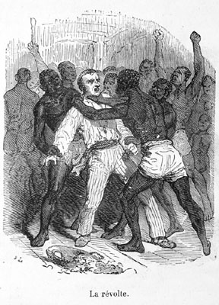

(http://hitchcock.itc.virginia.edu/SlaveTrade/collection/medium/LCP-14.JPG)

Source 4

'During the first part of the passage, our allowance of water was three pints per day: for the last month it was reduced to one quart, wine measure...happy I used to think to myself, though almost fainting with fatigue, if a little sweat dropped from my forehead, that I might catch it in my mouth to moisten my parched tongue. The licking the dew off the hen-coops, in a morning, had been long a delicious secret...Many of the men could not refrain, but in a kind of temporary distraction, drank up their whole allowance the moment they received it; and remained for the next twenty hours in a state of raging thirst not to be described. The doctor declared that this want for water, in such a climate, and living entirely on salt provisions, must lead to most fatal consequences.'

(Stanfield, James., Observations on a Guinea Voyage, in a Series of Letters to the Rev Thomas Clarkson, p13)

Source 5

'as soon as they are fairly out at sea, and there is no possibility of desertion, or application of justice, then the scene is shifted. Their ratio of provisions is shortened to the very verge of famine; their allowance of water lessened to the extreme of existence; nothing but incessant labour, a burning climate, unremitting cruelty, and every species of oppression is before them.

(Stanfield, James., Observations on a Guinea Voyage, in a Series of Letters to the Rev Thomas Clarkson, p10)

Source 6

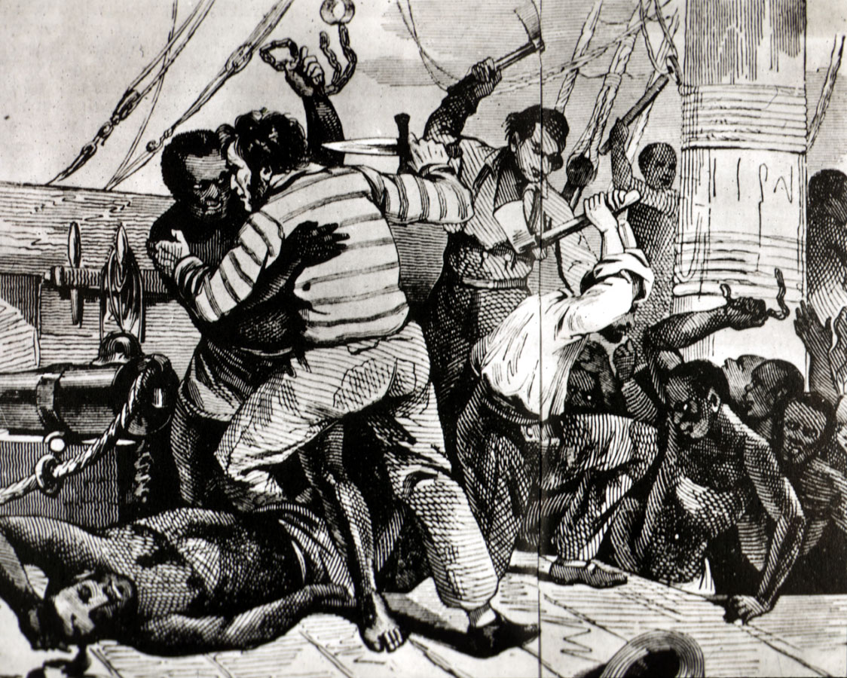

(http://hitchcock.itc.virginia.edu/SlaveTrade/collection/large/E006.JPG)

Glossary

severity - The fact or condition of being severe

pump-bolt - can't find, any ideas? Or leave it out...?

quarter-deck - The part of a ship's upper deck near the stern (the rear), traditionally reserved for officers

steerage - The action of steering a boat / equipment used to steer the boat

half-deck - A deck reaching half the length of a ship or boa

centinel (sentinel) - A soldier or guard whose job is to stand and keep watch

starboard - The side of a ship that is on the right when one is facing forward

providentially - Something that occurs in a fortunate manner

quart - A unit of liquid capacity equivalent in Britain to approximately 1.13 litres

hen-coops - A chicken coop is a building where female chickens are kept.

dew - Water droplets condensed from the air, usually at night, onto cool surfaces.

salt- provisions - Supplies with food, preserved with salt, especially for a journey

incessant – Continuing without interruption

unremitting - never slackening or stopping; unceasing; constant

Questions

- What would you (as a slave/sailor) have feared on the Middle Passage?

- What conditions would you have faced on-board?

- Who would have controlled you?

- How could you have died during the journey?

- How do you think you would have felt?

