Lesson Plan: The experiences of those on board the slave ships of the Middle Passage

Learning Intentions
- To understand the experiences of slaves and sailors on-board ships during the Middle Passage.
- To analyse sources.
- To discuss and debate a topic.
- To develop a line of argument and support it with reference to the sources.

Success Criteria
At the end of the lesson, I know I will be successful today if I…
- Understand the slave trade and middle passage,
- Understand the experiences of people on slave ships
- Understand the complexities of slave ships and people's roles

Starter Activity – 5 minutes
Display this image:  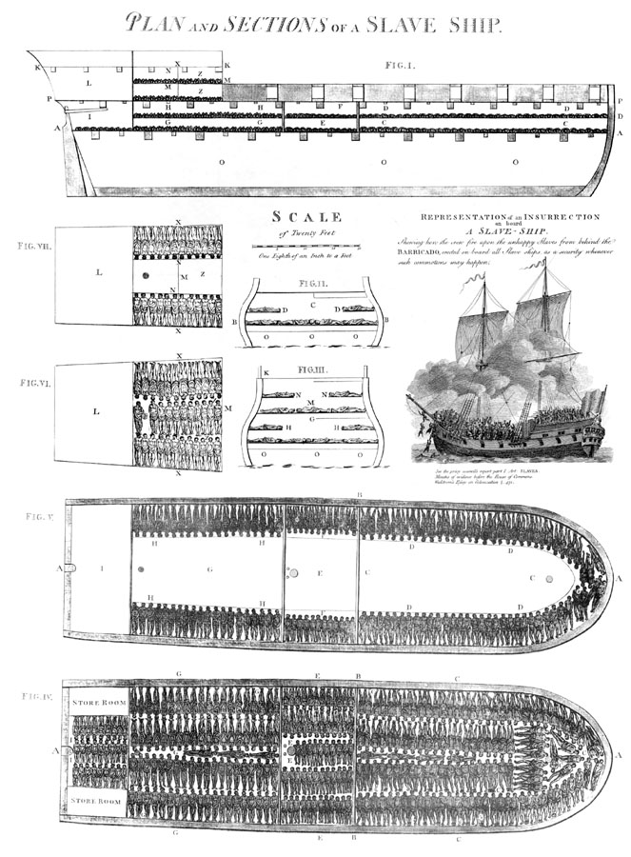  Alongside this image:  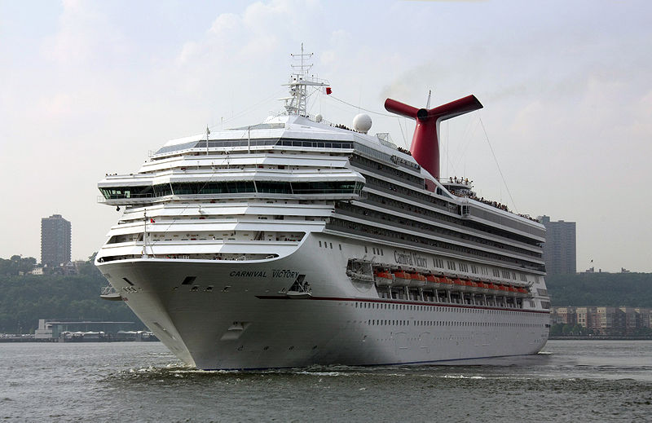  The images should prompt a discussion surrounding the number of people on board each ship, the conditions in which they travel and which experience the students would prefer.  Use the following information to explain the differences between the two, and to introduce the awful conditions in which slaves were transported:  - The first one is approximately 100ft in length and just over 20ft at its widest part and it carried 609 slaves.  - The cruise ship is 893ft long and 125ft wide and can carry max 3,470.  - So it carries just under 6x the number of people BUT is almost 9x longer and just over 6x wider.  - To give an example a football pitch is 393ft long so the slave ship is virtually a quarter of a pitch long whilst the cruise ship is roughly 2 and 1/3 pitches long  - A pitch is 150ft wide so the slave ship is around 1/8 of the width and the cruise ship is almost the same width. |  | This activity is designed to introduce the theme of the lesson and to challenge the students to consider the conditions on board a slave ship.  Presenting the differences between a slave ship and a cruise ship should help the students to understand the conditions in which slaves were transported.  Using equivalent measurements, such as those of a football pitch, should help the students to comprehend the scale of both of the vessels.
Main Activity – 30 minutes
Sources – 15 minutes  Split the class into two groups. One will consider the experiences of the slaves, and the other will consider the experiences of the sailors.  Give each group their selection of sources. In smaller groups, they will be required to read/look at the sources and to use them to write answers to the following questions:  - What would you (as a slave/sailor) have feared on the Middle Passage?  - What conditions would you have faced on-board?  - Who would have controlled you?  - How could you have died during the journey?  - How do you think you would have felt?  Discussion/Debate – 15 minutes  Using the questions above, and the students’ notes, lead a discussion/debate surrounding the experiences of those on board ships during the Middle Passage.  Explain to the class that they will need to use the sources they have looked at to back up their points. They will need to listen to both sides of the debate, as they will need to understand the other group’s experience.  You could begin by asking, “what would you (as a sailor/slave) have feared on the journey?”. Encourage the students to consider that conditions were poor for both groups.  Additional:  You could introduce the roles of the Captain and/or slave guardians. This would allow the students to further appreciate the complexities of life on board a slave ship. | The use of the sources fulfils one of the main skill objectives of the lesson. They are required to take notes in order to record the information that they find during the activity. The combination of written and pictorial sources is intended to retain their attention and to demonstrate the wide variety of sources that can be used in historical research. By using some sources for both groups, it is possible to show that a source can be interpreted in different ways and used to support more than one point of view.  The debate is designed to encourage the students to engage with the source material in a more active manner. They will be using what they have read/looked at to support their points as they work as a group to present their sailor/slave experience.  The questions should help to begin and continue the activity, and can be used as prompts if discussion dries up.  By the end, students should appreciate the complex nature of slave ship society and the experience of both sailors and slaves on-board.
Plenary – 10 minutes
‘Diamond Game’  Students will remain in their Slaves/Sailors groups and compete to be the first team to successfully cross the board.  Each diamond requires a student to correctly answer the question associated with it. If they are correct, the team can choose another connecting diamond and attempt another question.  7  Example of the board:  8  12  2  28  27  25  18  20  3  19  24  16  9  17  21  26  14  31  23  15  22  11  30  10  6  32  13  29  5  4  1  Example questions:  - Who was Alexander Falconbridge?  - What were the sailors afraid of?  - What weather conditions did the ships face?  - How long did the journey take?  - How much space did each slave have to live in?  - How healthy were those on board?  - What were the slaves afraid of?  - Name a way in which people on board could die.  - Who was on board a ship during the Middle Passage?  - Where did the ships sail from, and to?  - Name an illness a slave may have on the ship?  - Who was in charge of the ship?  - Were the slaves on board the ship all from the same place?  - What was a slave guardian?  - If a slave, who was in control of you?  - Who lived in better conditions: slaves or sailors?  - Who was Thomas Phillips?  - How could a slave be abused?  - Could a slave escape a slave ship? How?  - Did many slaves die on board a ship? |  | This activity is designed to consolidate the information that students have learnt during the lesson. It is intended to be fun and to use competition to encourage all members of the class to take part.  The questions are designed to cover all the elements of the lesson (source use, interpretation, discussion) and each group will be required to answer questions concerning the ‘other side’ of the debate, thus they need to have paid attention to both sides during the previous exercise.  The questions could easily be adapted to cover previous areas of study, such as West African culture, or earlier lessons on the Middle Passage.

