

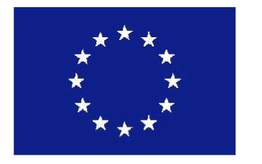


Marie Curie International Outgoing Fellowships for Career development
Call identifier: FP7 . PEOPLE . 2007.4-1-IOF
Proposal N° 219671 - SEGREG-INTEGRATION

Between Segregation and Social Integration:
Recent Immigrants and Foreign Workers in the USA and in the UK

REGISTRATION

I confirm that I will attend the above workshop on 28 June 2010
At the University of Glasgow
The Wolfson Medical School, Seminar Room 1 (Yudowitz)

Registration 09.30
_____________________________________________________________________

Name:

Affiliation (Institution, Department):

Address:

Position:

Contact details
Email:

Phone:

Special Dietary Requirements:

Please return this form to Mrs Maggie Baister by 18 June 2010
m.baister@lbss.gla.ac.uk
University of Glasgow, Department of Central and East European Studies
8-9 Lilybank Gardens, Glasgow G12 8RZ, UK

