
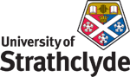
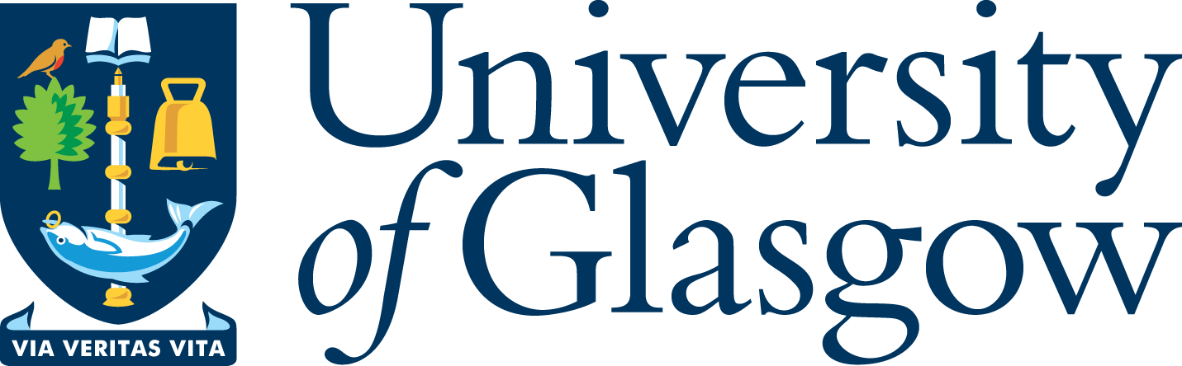

‘West Coast Seminars’
on
Economic and Social Change in Russia and Eastern Europe
(Glasgow, West of Scotland [Paisley campus] and Strathclyde Universities)

Fifteenth Annual Series: 2008-09

“The Stalinist Self: The Case of Ioseb Jugashvili (the young Stalin, 1898-1907)”

Dr Erik van Ree

University of Amsterdam

Wednesday 21 January 2009
at 5.30 pm

University of Glasgow

CEES Seminar Room, 8-9 Lilybank Gardens

Tea and coffee will be available from 5.00

All Welcome

Dr Erik van Ree is assistant professor at the “Oost Europa Instituut”, department of European Studies at the University of Amsterdam. He is the author of The Political Thought of Joseph Stalin (Routledge 2002)

* for further details please contact
Prof Terry Cox, University of Glasgow 0141 330 2343 t.m.cox@lbss.gla.ac.uk
Dr Irene McMaster, University of Strathclyde 0141 554 4905 irene.mcmaster@strath.ac.uk
Prof Martin Myant, University of West of Scotland 0141 848 3367 martin.myant@uws.ac.uk

