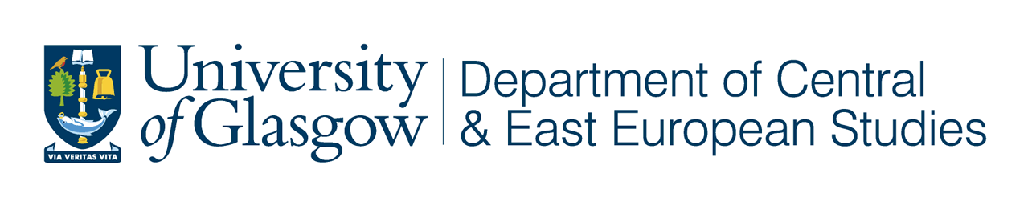

Guest Research Seminar

“The Altai Region:

its culture and sociological science”

Dr Anna Maltseva
Faculty of Sociology, Altai State University, Russia
CEES Visiting Research Fellow

Tuesday 17 February 2009
at 5.30 pm

University of Glasgow

CEES Seminar Room, 8-9 Lilybank Gardens

Tea and coffee will be available from 5.00

All Welcome

We are very pleased to welcome our current visiting research fellow to the Department of Central and East European Studies.

Dr Anna Maltseva is from the Faculty of Sociology at Altai State University, Barnaul, Russia where she is Head of the laboratory of statistical support of sociological and psychological researches and Associate Professor of the chair of mathematical methods in social sciences. Her current area of interest is education, in particular the role of social identity of modern student youth and its influence of the decision making process.

Dr Maltseva will give an introduction to and overview of the region, followed by discussion about sociological research trends at the Faculty of Sociology at the Altai State University. She will welcome the opportunity to meet new colleagues and share ideas.

