
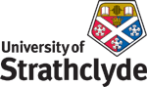
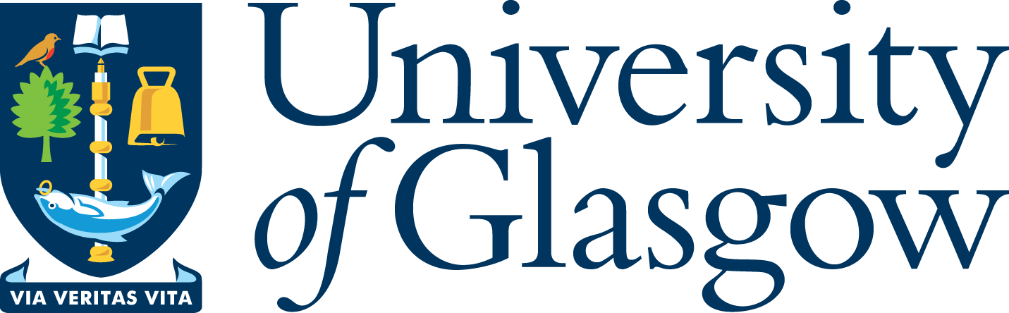

‘West Coast Seminars’
on
Economic and Social Change in Russia and Eastern Europe
(Glasgow, West of Scotland [Paisley campus] and Strathclyde Universities)

Fifteenth Annual Series: 2008-09

‘ The Rise and Fall of the EU Roma Strategy’

Dr Katherine Lebow

University of Virginia

Wednesday 11 March 2009
at 5.30 pm

University of Glasgow

CEES Seminar Room, 8-9 Lilybank Gardens

Tea and coffee will be available from 5.00

All Welcome

Dr. Lebow, an assistant professor of history at the University of Virginia until 2008, is currently a visiting fellow at the University of Edinburgh. Her book Socialism in One City: Nowa Huta and the Transformation of Poland, 1949-1989 is forthcoming from Princeton University Press.

Abstract;
The paper examines Stalinist mobilization campaigns in Nowa Huta --Poland's 'first socialist city'-- during the early- to mid-1950s, a time when (according to one activist) every aspect of life in the new town was 'agitation, a momentous kind of politics.' It proposes that the micro-politics of everyday life and work under Stalinism, set against the backdrop of the era's broader social and political changes, are key for understanding the subsequent emergence of worker opposition in Poland.

* for further details please contact
Prof Terry Cox, University of Glasgow 0141 330 2343 t.m.cox@lbss.gla.ac.uk
Dr Irene McMaster, University of Strathclyde 0141 554 4905 irene.mcmaster@strath.ac.uk
Prof Martin Myant, University of West of Scotland 0141 848 3367 martin.myant@uws.ac.uk

