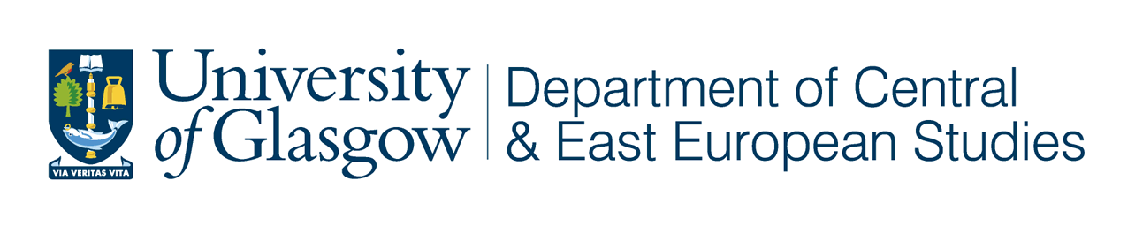



‘West Coast Seminars’
on

Economic and Social Change

in Russia and Eastern Europe
Fifteenth Annual Series: 2008-09

Department of Central and East European Studies
Department of Politics

in association with the West Coast Seminar Series

‘The Role of Culture in Nation Branding’

Brigita Stroda
Director of Latvian Tourism, London

Thursday 27 November 2008
at 5.30 pm

University of Glasgow

CEES Seminar Room, 8-9 Lilybank Gardens

Tea and coffee will be available from 5.00

All Welcome

Successful branding is worth its weight in gold. For an intangible commodity that lives inside the head of the beholder, this is powerful stuff. Nation branding is more complex but often the key to economic viability. For small countries, if done well, it will allow them to punch above their weight in competitiveness. I will look at the significance of the role that culture plays in this field, and use a specific example from the city of Riga in the field of tourism.


Born in multicultural Australia to Latvian parents, Brigita, educated as a set designer, has spent most of her working life in arts management in Australia and for a short time in France. Heeding the call of a newly independent Latvia, The Latvian National Opera was a logical place to indulge a commitment to nation building, with some success, for nine years. This was followed by a stint at the Riga Convention Bureau leading to a new position as the Director of the Latvian Tourism Development Agency office in London. An active member of the European Cultural Parliament, Brigita is fascinated by all manner of issues pertaining to identity, and the strategic use of culture to achieve a dynamic and workable Europe.

