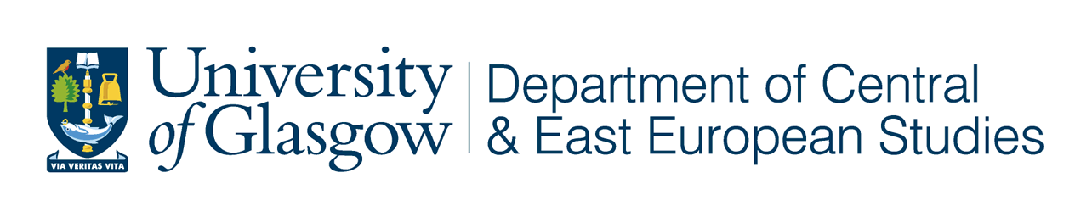

in conjunction with
Department of Sociology and Anthropology
International Centre for Gender and Women’s Studies
The West Coast Seminar Series
(Universities of Glasgow, West of Scotland (Paisley Campus) and Strathclyde)

Guest Research Seminar

POST-SOVIET MASCULINITIES, SHAME and
the ARCHIVES OF SOCIAL SUFFERING
in CONTEMPORARY LITHUANIA

Arturas Tereškinas
Vytautas Magnus University, Lithuania
Visiting Research Fellow
Department of Central and East European Studies

Tuesday 21 October 2008
at 5.30 pm

University of Glasgow

Room T316 Adam Smith Building

Tea and coffee will be available from 5.00

All Welcome

Arturas Tereškinas is Associate Professor in the Department of Sociology at Vytautas Magnus University, Lithuania. His current research examines how Lithuanian men construct their masculinity in relation to work, family, fatherhood, citizenship, sexuality, health, disability and cultural representation - tracing changes in male practices and perceptions of masculinity from 1990- 2008.
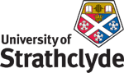

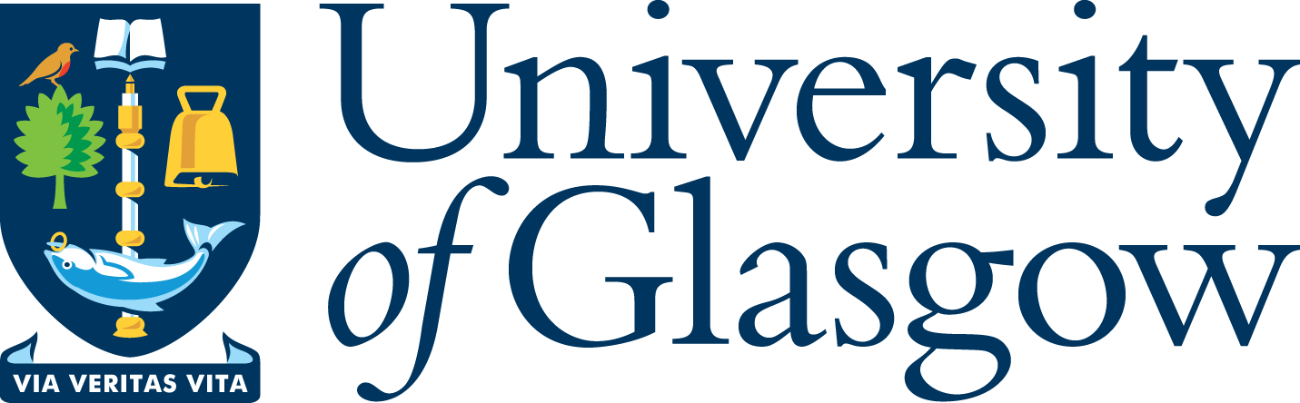
‘West Coast Seminars’
on

Economic and Social Change

in Russia and Eastern Europe
Fifteenth Annual Series: 2008-09

