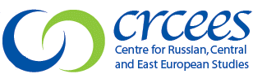
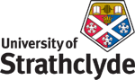
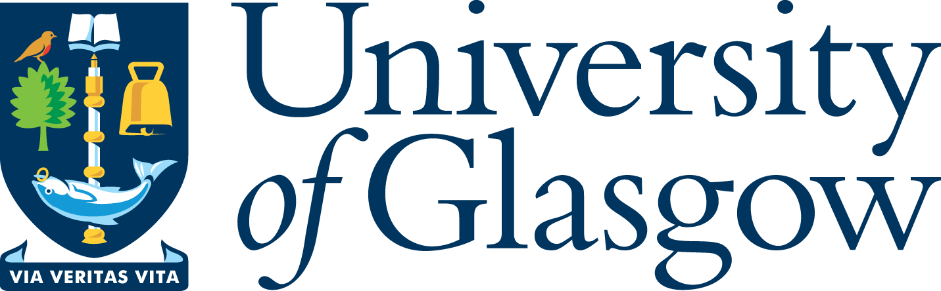

‘West Coast Seminars’
on
Economic and Social Change in Russia and Eastern Europe
(Glasgow, West of Scotland [Paisley campus] and Strathclyde Universities)

Fifteenth Annual Series: 2008-09

“Structure, Agency and Resource Curse:
Azerbaijan’s Efforts to Minimise the Curse and Maximise the Blessing”

Murad Ismayilov
Baku State University and Azerbaijan Diplomatic Academy
CEES Visiting Fellow

Wednesday 19 November 2008
at 5.30 pm

University of Glasgow

CEES Seminar Room, 8-9 Lilybank Gardens

Tea and coffee will be available from 5.00

All Welcome

Murad Ismayilov is in the final year of his PhD at the Baku State University (Azerbaijan) and in the second year of an MSt at the University of Cambridge. He is also a research fellow and projects coordinator (research and publications) at the Azerbaijan Diplomatic Academy. He also teaches at the Baku State University (BSU) where, as an OSI AFP fellow, he is actively involved in the renovation and reformation processes within the International Relations Department, aiming to transform the Department to meet the Bologna requirements. His research interests include international relations theory (especially constructivist and post-structuralist approaches), political theory, energy security, issues related to national identity and civil society of Azerbaijan, Azerbaijan’s national security, Euro-Atlantic security, and sociology and security of the Middle East.

* for further details please contact
Prof Terry Cox, University of Glasgow 0141 330 2343 t.m.cox@lbss.gla.ac.uk
Dr Irene McMaster, University of Strathclyde 0141 554 4905 irene.mcmaster@strath.ac.uk
Prof Martin Myant, University of West of Scotland 0141 848 3367 martin.myant@uws.ac.uk

