
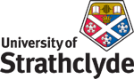
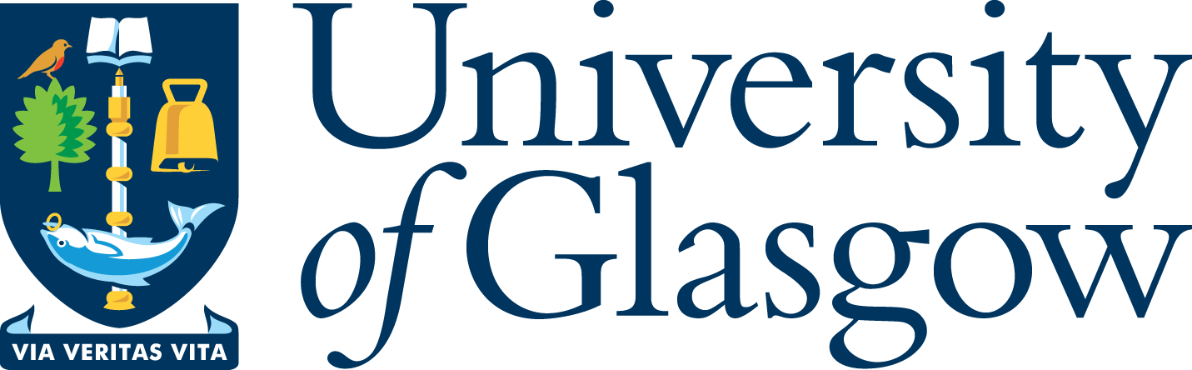

‘West Coast Seminars’
on
Economic and Social Change in Russia and Eastern Europe
(Glasgow, West of Scotland [Paisley campus] and Strathclyde Universities)

Fifteenth Annual Series: 2008-09

Informal discussions on Hungarian Politics
(no formal paper)

Dr Sándor Gallai
Corvinus University, Budapest

Tuesday 11 November 2008
at 5.30 pm

University of Glasgow

CEES Seminar Room, 8-9 Lilybank Gardens

Tea and coffee will be available from 5.00

All Welcome

Sándor Gallai is Vice Dean of the Faculty of Social Sciences and Associate Professor in the Institute of Political Sciences, University of Corvinus. He is an expert in Hungarian politics especially on governance and state-society relations in Hungary.

* for further details please contact
Prof Terry Cox, University of Glasgow 0141 330 2343 t.m.cox@lbss.gla.ac.uk
Dr Irene McMaster, University of Strathclyde 0141 554 4905 irene.mcmaster@strath.ac.uk
Prof Martin Myant, University of West of Scotland 0141 848 3367 martin.myant@uws.ac.uk

