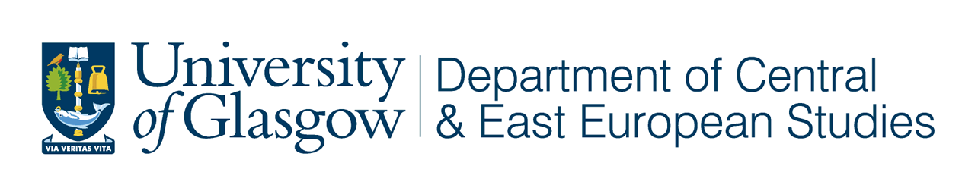
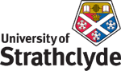
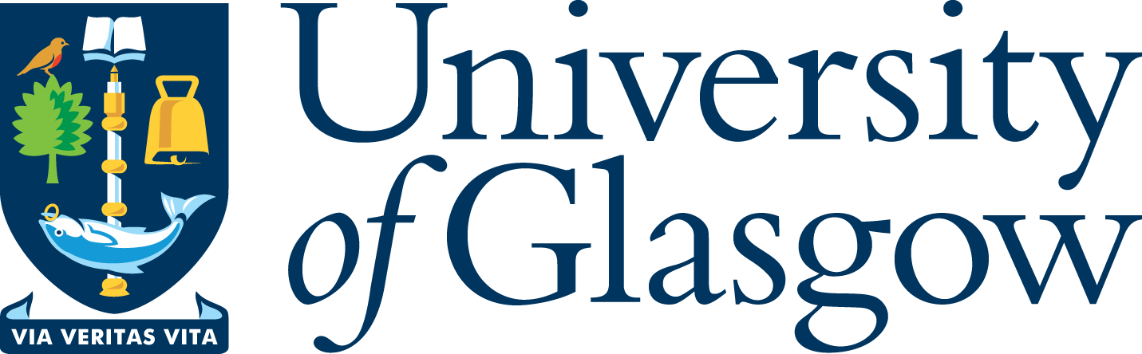

‘West Coast Seminars’
on

Economic and Social Change

in Russia and Eastern Europe
Fifteenth Annual Series: 2008-09

Department of Central and East European Studies
Department of Politics

in association with the West Coast Seminar Series

“Women, welfare and legal claims in contemporary Russia: new definitions and approaches to claiming rights”

Dr Vikki Turbine
Department of Politics, University of Glasgow

Wednesday 04 February 2009
at 5.30 pm

University of Glasgow

CEES Seminar Room, 8-9 Lilybank Gardens

Tea and coffee will be available from 5.00

All Welcome

The processes of marketisation and privatisation in the postsocialist period have resulted in the transformation of welfare provision in Russia and the re-inscription of private responsibility for welfare protection. Drawing on in-depth interview data with women living in the provincial Russian city of Ul’ianovsk in 2005, this paper highlights how some women are responding to these transformations by engaging with ‘formal’ approaches, such as seeking legal advice and making legal claims, both against the state and in inter-family disputes.

Vikki Turbine is lecturer in the department of Politics, University of Glasgow. Her research interests centre around gender, justice and human rights with a particular reference to the contemporary Russian context. Her current research explores the processes and actors involved in the development of legal consciousness in Russia and whether this enhances or destabilises women’s access to rights.

Prof Terry Cox, University of Glasgow (CEES) 0141 330 2343 t.m.cox@lbss.gla.ac.uk
Prof Brian Girvin, University of Glasgow (Politics) 0141 330 5353 b.girvin@lbss.gla.ac.uk
Dr Mo Hume, University of Glasgow (ICGWS) 0141 330 4683 m.hume@lbss.gla.ac.uk
Dr Irene McMaster, University of Strathclyde 0141 554 4905 irene.mcmaster@strath.ac.uk
Prof Martin Myant, University of West of Scotland 0141 848 3367 martin.myant@uws.ac.uk

Department of Central and East European Studies
Department of Politics
in association with the West Coast Seminar Series

Vikki Turbine, 04 February 2009

Women, welfare and legal claims in contemporary Russia: new definitions and approaches to claiming rights?

The processes of marketisation and privatisation in the postsocialist period have resulted in the transformation of welfare provision in Russia and the re-inscription of private responsibility for welfare protection. These processes have had gendered consequences and women generally remain responsible for securing their own welfare and the welfare of their families. Much existing research on women and welfare in Russia has highlighted women’s ‘retreat’ to the private sphere and use of informal and collective approaches. However, there is less research focusing on women’s use of formal approaches in everyday life. Drawing on in-depth interview data with women living in the provincial Russian city of Ul’ianovsk in 2005, this paper highlights how some women are responding to these transformations by engaging with ‘formal’ approaches, such as seeking legal advice and making legal claims, both against the state and in inter-family disputes. This paper considers the extent to which women’s use of legal approaches is a ‘new’ approach in response to marketisation, and whether it is signifies an effective adaptation of former approaches to the constraints presented by postsocialist market conditions. The paper further argues that far from being an effective means of securing welfare, such approaches can be disempowering for women as the individualistic and legalistic nature of the process obscures wider structural constraints and can as a result delegitimise women’s welfare claims against the state and also within the family. Further analysis of women’s use of formal legal approaches in contemporary Russia is therefore required and plans for a proposed research project on this topic are outlined for discussion.

