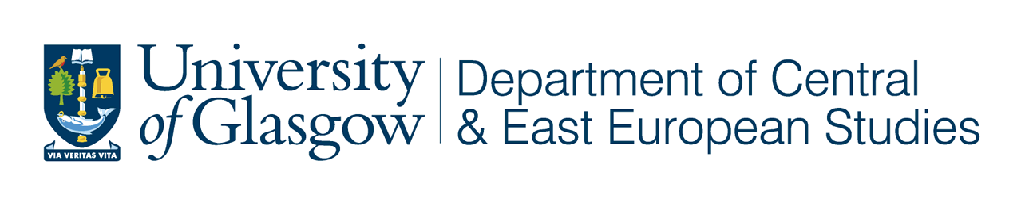
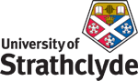
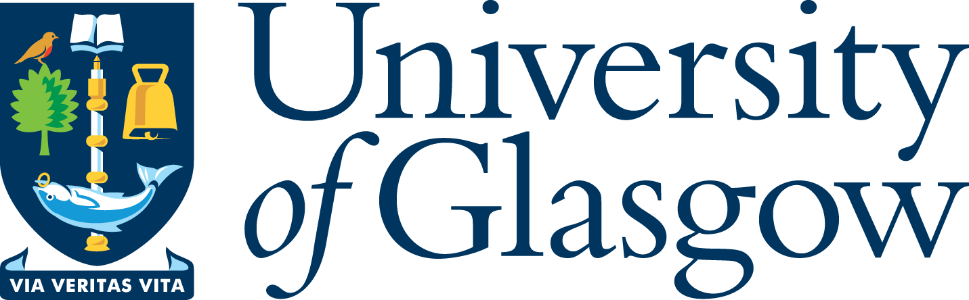
‘West Coast Seminars’
on

Economic and Social Change

in Russia and Eastern Europe
Fifteenth Annual Series: 2008-09

Department of Central and East European Studies
Department of Sociology, Anthropology and Applied Social Sciences

in association with the West Coast Seminar Series

“Soviet Modernity and the ‘modern homosexual’: Researching lesbian sexuality through an oral history project”

Francesca Stella
CEES and SAASS, University of Glasgow

Wednesday 03 December 2008
at 5.30 pm

University of Glasgow

CEES Seminar Room, 8-9 Lilybank Gardens

Tea and coffee will be available from 5.00

All Welcome

The categories of male and female homosexual entered Russian culture in the late 19th century, as part of a wider repertoire of medical and legal discourses coming from Western Europe. As in other modernising societies, such discourses were part of a broader set of strategies designed to manage and control population growth and urbanisation.

Francesca Stella is a lecturer at the department of Central and East European Studies, and a tutor at the Department of Sociology, Anthropology and Applied Social Sciences, University of Glasgow. She recently completed her PhD on lesbian identities and everyday space in contemporary urban Russia.

Prof Terry Cox, University of Glasgow (CEES) 0141 330 2343 t.m.cox@lbss.gla.ac.uk
Dr Matthew Waites, University of Glasgow (SAASS) 0141 330 4049 m.waites@lbss.gla.ac.uk
Dr Mo Hume, University of Glasgow (ICGWS) 0141 330 4683 m.hume@lbss.gla.ac.uk
Dr Irene McMaster, University of Strathclyde 0141 554 4905 irene.mcmaster@strath.ac.uk
Prof Martin Myant, University of West of Scotland 0141 848 3367 martin.myant@uws.ac.uk

“Soviet Modernity and the ‘modern homosexual’: Researching lesbian sexuality through an oral history project”

Francesca Stella
CEES and SAASS, University of Glasgow

Wednesday 03 December 2008

Abstract

The categories of male and female homosexual entered Russian culture in the late 19th century, as part of a wider repertoire of medical and legal discourses coming from Western Europe. As in other modernising societies, such discourses were part of a broader set of strategies designed to manage and control population growth and urbanisation. The experience of state socialism, which marked a fundamental moment in Russia’s trajectory to modernity, contributed to shape Russian notions of homosexuality. Existing literature on Soviet homosexualities has typically focused on legal and medical discourses, emphasising the repressive role of state institution and of the ‘new Soviet morality’ in enforcing heteronormativity. However, experiences of same-sex relations are very sparsely documented in the literature, and little attention has been given to the ways in which female same-sex relations were lived, experienced and negotiated in the late Soviet period.

The paper that will be presented at the seminar is based on interviews collected for a previous study among older lesbian and bisexual women in Moscow and Ul’ianovsk. The paper discusses empirical data within the framework of existing literature on Soviet homosexuality and of broader academic debates on the ‘modern homosexual’. It emphasises the peculiarities of the Soviet gender order, while suggesting the need to depart from arguments framing Soviet repression of homosexuality predominantly within a ‘totalitarian’ framework. It also explores avenues to further explore the topic of female homosexuality in the late Soviet period, and outlines the main lines of enquiry of a research project ‘in the making’, based on oral history interviews and the analysis of medical texts.

Francesca Stella is a lecturer at the department of Central and East European Studies, and a tutor at the Department of Sociology, Anthropology and Applied Social Sciences, University of Glasgow. She recently completed her PhD on lesbian identities and everyday space in contemporary urban Russia.

