Dr Ghassan S. Abu-Sittah MBchB, FRCS(Plast) 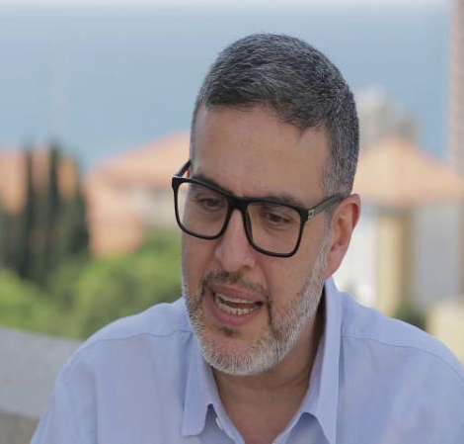
Rector

Mr Ghassan Abu-Sittah is a British-Palestinian Associate Professor of Surgery and a Plastic & Reconstructive Surgeon. He completed his medical education at University of Glasgow in the U.K and his postgraduate residency training in London. He later underwent 3 fellowships: Pediatric Craniofacial Surgery at Great Ormond Street Hospital for Sick Kids (GOS); Cleft Surgery at GOS and a further fellowship in Trauma Reconstruction at the Royal London Hospital.

In 2011 he was recruited by the American University of Beirut Medical Center. In 2012 he became Head of the Division of Plastic and Reconstructive Surgery at the AUBMC, Clinical Lead of its Paediatric War injuries program and War Injuries Multidisciplinary Clinic. In 2015 co-founded and became director of the Conflict Medicine Program at Global Health Institute at the American University of Beirut. He returned to the UK in 2020 and continues in Plastic and Reconstructive Surgery in the private sector.

He is an Honorary Senior Clinical Lecturer at the Center for Blast Injury Studies at Imperial College University of London and Visiting Senior Lecturer at the Conflict & Health Research Group at Kings College London University. He is Clinical Lead for the Operational Trauma Initiative at the World Health Organization’s EMRO Office and serves on the board of directors of INARA, a charity dedicated to providing reconstructive surgery to war injured children in the Middle East, and Board of Trustees of the UK based Medical Aid for Palestinians. He serves on the UK’s National Institute of Health Research (NIHR) International Funding Committee.

He has published extensively on the health consequences of prolonged conflict and on war injuries including a medical text book, “Reconstructing the War Injured Patient” and “Treating the War Injured Child.” He has worked as a war surgeon in Yemen, Iraq, Syria, South Lebanon and during the 4 wars in the Gaza Strip.

On the 9th of October 2023 he entered the Gaza Strip and worked in Shifa Hospital and then Al- Ahli-Baptist Hospital for 43 days during the current. Evidence he provided was part of the South African submission to the International Court of Justice. His work was featured by numerous newspapers and media outlets notably La Monde, The Independent, Telegraph, BBC and CNN.

