MVLS Public and Patient Involvement and Engagement  Our Year in Numbers 2023 |  | We enable public and patient involvement in research to improve health and quality of life | 3  Public contributor co-applicants on proposals | 4  Steering group meetings  17  Study Management group meetings  13  Patient Advisory Group meetings
30  Grants and Ethics applications reviewed before submission | New public contributors to shape research  8 | 2  Glasgow Research Involvement Newsletters (GRIN) | 2  Engagement reports  2  Research Updates  2  Guidance  and support publications
7  Workshops  3  Training events | Evaluation of Public and Patient Involvement  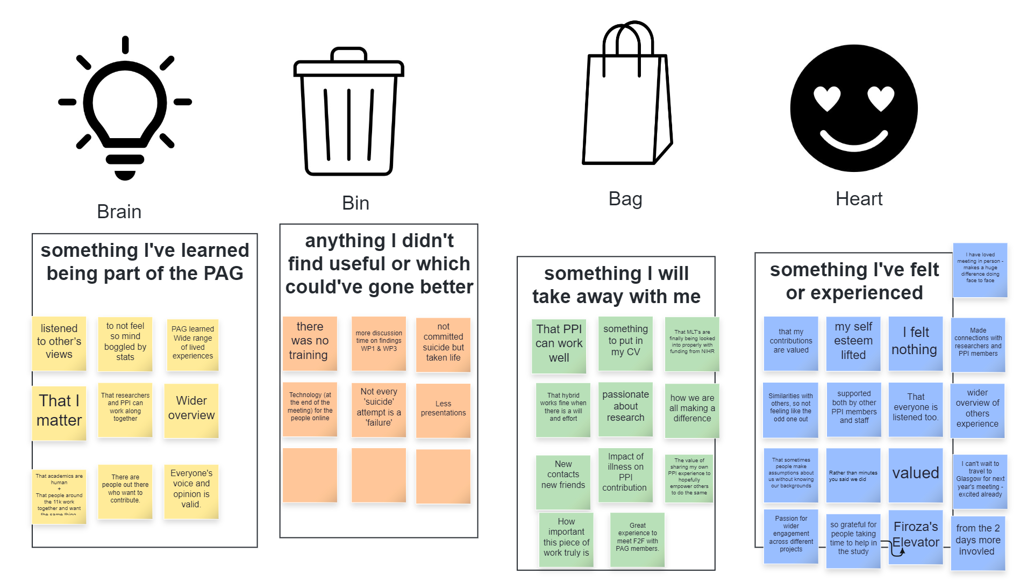 |  |  | GET INVOLVED !  Mvls-ppie@glasgow.ac.uk  @UofGInvolve
This cover has been designed using images from Flaticon.com

